**SAKO TRG-42 SNIPER RIFLE**

**Intro**

1**.** SAKO TRG-42 sniper Rifle ek Bolt-action repeating Rifle hai jis mein magazine detachable hai. Trg - 42 Rifle ke construction ke vishesta base raile hai. Jismein receiver,base rail cover ke saath fore end or folding stock ko joda gaya hai. Barreled action solid mounting ke vajah se is ke accuracy power kafi jyada hai. Iske alawa front end ke sath rear stock, jo base rail per lagya gaya hai, ka TRG rif ki final accuracy per koi prabhav nahi padta hai. TRG 42/22 ke version ka anter kevel chune gaye calliber ke karan receiver, Bolt or mag ka akar hai. Jab bhi ek markhsmen high operating Safety, excellient handeling, dwara use kiya jata hai to wpn ka main feature wpn ki pin point accuracy mana jata hai.In features ke karan yeh wpn military snipers or units dwara upyog ke liye vishesh roop se suitable hai. Receiver ke upper MIL-STD 1913 rail or MMRS rail sahi tarike se jude hone ke karan alag alag aiming device lagane ki anumati deta hai (Day Scope, Night sight/night vision device aur laser point/ Tgt designator). Military, training, firing and regiment.

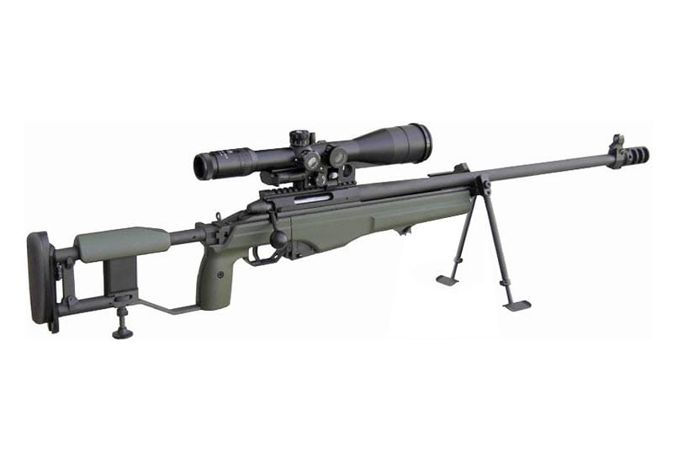

**Tech Data**

a) Brand - SAKO

b) Model - TRG-42

c) Country origin - Finland

d) Operation - Manual operated Bolt action

e) Calibre - .338’’ (8.6 × 70mm)

1. **Weight**

1. Khali Rif - 5.3 kg
2. Scope - 1.024kg
3. Bhari rif with scope - 6.726kg
4. Khali mag - 187gm
5. Bhari mag - 402gm
6. Bolt - 406gm

2. **Length**

1. Fully extended butt - 1205mm
2. Folded butt - 990mm
3. Barrel - 690mm
4. Rifling pitch - 254mm 1 turn
5. Low Bipod - 300mm
6. High Bipod - 410mm
7. Cheeck pad movement - 50mm

3**.** **Ballastic**

1. Cart case - 8.6 × 70mm (Rimless)
2. Wt - 43gm
3. Bullet wt - 250 grain (16gm)
4. Envlope - Gilding metal
5. Carts length - 90mm

4. Trigger pull - 1.3 – 2.3 kg

5. Muzzle velocity - 900m/s

6. Bolt Through - 118mm

7. Firing Pin Movement - 6.5mm

8. Mag Capacity - 05 Rds

9. Mech Safety - Lock

10. Applied Safety - Trigger Safety

11. Body material - Alloy Aluminium P

12. Barrel - Steel (Non chromium plated) Cold hammer

Forged

13. Optical Sight/NVD - MIL STD -1913(Picatinny) MMRS Interface 30 MOA

14. Recoil pad - Polyurethane Rubber

3. **Visheshtayen :-**

(a) Bolt Action weapon.

(b) High operating Safety.

(c) Free Floated or Removable Barrel.

(d) Adjustable Trigger.

(e) High Mag scope.

(f) Din or Raat ke liye alag alag sighting System.

(g) Bipod ki suvidha.

(h) Kam Recoil .

(j) Base Rail, ITRS aur MMRS ki suvidha.

(k) Standard units or dimensions ke sath iski banawat.

(l) Butt stock adjustable hone ke karan baayen or daayen hath ke firer ke liye ek saman istemal karne yogya.

(m) Steel plate magazine.

(n) .338 Lapua Magnum Amn.

(o) Snap shooting ke liye aasan.

(p) Manual operated.

(q) Adjustable cheek pad, Recoil pad or Mono pad ki suvidha.

**Hathiyar ke mukhya hisse purje :-**

4. SAKO TRG - 42 sniper Rifle nimn hisse purjon se milkar bani hai.

(a) Barreled receiver

(b) Bolt

(c) Base rail and ITRS or MMRS rail

(d) Rear stock

(f) Fore-end

(g) Trigger mechanism

(h) Magazine

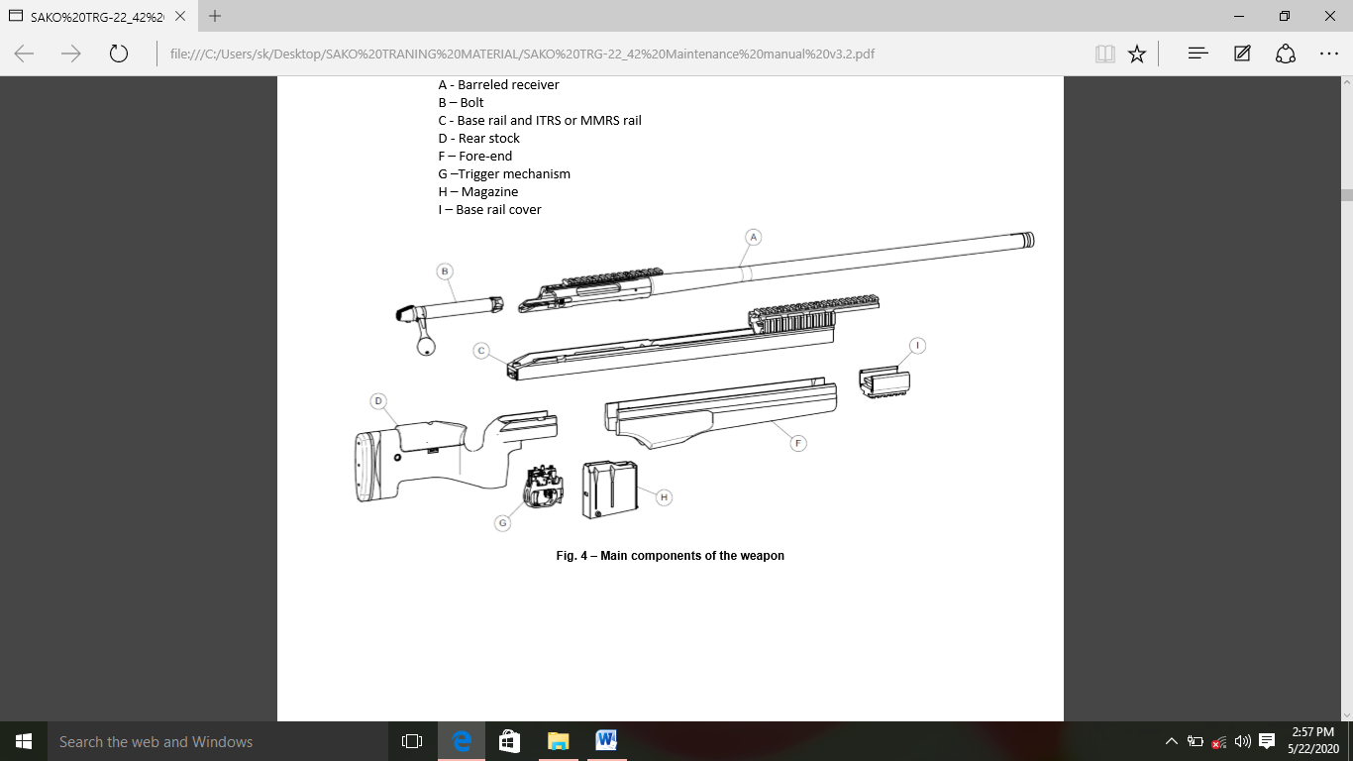(j) Base rail cover

(a) **Barreled Receiver**

(i) **Barrel**

(aa) Iski Barrel cold-forged hai or usme four right-hand grooves hain.

(ab) Barrel ko Reciever ke sath M27 x 1.5 thread ki madad se attach kiya gaya hai.

(ac) Muzzle Attachment (muzzle brake or suppressor) ke liye M18 x 1 thread diya gaya hai.

(ad) Muzzle par muzzle brake ke thread ke extension ke roop mein optional front sight ko align karne ke liye ek milled grooves diya gaya hain.

(ii) **Receiver** Receiver ko steel blank se tayar kiya gaya hai.

(aa) Ek Rifle scope ke aadhar ke sath sath optional auxillary peep sight ke liye longitudinal mounting grooves receiver ke upari hisse par milled kiya gaya hai. Mounting base ke recoil lug ke liye transverse grooves ko longitude mouting grooves ke beech mein milled kiya gaya hai.

(ab) Bolt stop ke liye slot ko receiver ke peeche or dahine or attach kiya jata hai.

(ac) Trigger mech ke liye slot reciever ke peeche ke hisse par attach kiya gaya hai.

(ad) Base rail par dabaye gaye recoil lug ke liye mounting grooves reciever ke samne ke hisse ke base par attach kiya gaya hai.

(ae) Reciever ke base par teen M-6 Thread hote hain, jinka uupyog upukat screw ke sath kiya jata hai or receiver ko base rail ke sath attach kiya jata hai.

(af) Interior shape ko engg kiya gaya hai taki receiver Bolt movement ko guide karein. Bolt action ke dauran Bolt ke teen locking lugs receiver ke respective grooves ke sath harkat karta hai. Receiver ke samne ke hisse locking surface banate hain jis par Bolt close hone par Bolt ke locking lug rest karte hain. Locking lugs ke trialing edge ko locking slope banane ke liye beld kiya gaya hai, jo Bolt ko closing karne mein sakhsaham banate hain.

(ag) Receiver ke dahine taraf Bolt handle ke liye milled slot hai. Slot ke upari hisse ko caming slope ke roop meinn karya karne ke liye beld kiya gaya hai, jo slot ke baad Bolt ko open karne mein madad karta hai.

(b) **Bolt Assembly**

(i) Bolt head mein recces Bolt face hai, jo Bolt close hone par catridge case ke head ke liye rest surface ka kaam karta hai.

(ii) Bolt ke samne ke hisse mein 3 locking lugs hote hain, jo Bolt movement ke dauran Bolt ko operate karte hain or jab Bolt close ho jata hai to reciever ke khilaf locking surface ke roop mein kaam karta hai.

(iii) Bolt ke pichle hisse par M-6 thread ka upyog karke Bolt handle ko bandha jata hai. Bolt ke handle mein polymer knob hai. Jab Bolt khola jata hai, to Bolt ke pichle hisse par round caming surface ke samaksh kaam karti hai.

(iv) Locking lugs ke beech extractor ke liye ek milled slot or extractor plunger or extractor spring ke liye ek bore hota hai. Extractor case head ke khaanche ko pakadata hai or Bolt kholen jaane par nikal diye case ya bina fire kiye gaye catridge ko chamber ko bahar nikalta hai.

(v) Bolt face par , extractor ke viprit spring operated ejector or ejector spring ke liye ek bore hota hai. Ejector ko spring pin se baandha jata hai. Jab bBolt apni sabse peeche posn mein aa raha hota hai, to ejector fired catridge case ya bina fire kiye catridge ko ejection pot ke madhyam se bahar faink deta hai.

(vi) Bolt face ke beech mein ek hole hota hai, jiske madhyam se Firing pin primer se takrati hai, jab Rifle se fire kiya jata hai. Cocking piece firng pin assembly ke pcihle hisse par ek pin secured press joint ka upyog karkek taya kiya gaya hai. Jab Rifle se goli chlayi jati hai, to Bolt ke andar sthit kandhe ke samne, coking piece ke samne ke hisse par khaancha Firing pin ki harkat ko takrakar seemit karta hai.

(vii) Cocking piece ke pichle hisse ko coking noch ke aakar ka banaya gaya hai, ek gol samne ki satah jisme slide hoti hai, ajab Bolt khola jata hai, coking satah ke sath sath coking ke antt mein sthit apne arram karne wale khaanche mein ruk jata hai. Bolt ka pichla sira coking piece ke andruni hisse ko kandhe ke aakar ka banaya gaya hai, jiske khilaf trigger mech ka sear Rifle ko cock karta hai.

(viii) Cocking piece or Bolt shroud ke beech ikathe hue Firing pin spring ko Bolt ko ikatha karnen par iski initial posn mein tanav diya jata hai. Bolt shroud ke samne ke hisse mein 2 locking lugs hote hain, jo Bolt ke peeche ke hisse mein machinery grooves mein Bolt shroud ko pakadte hain, is prakar Bolt .

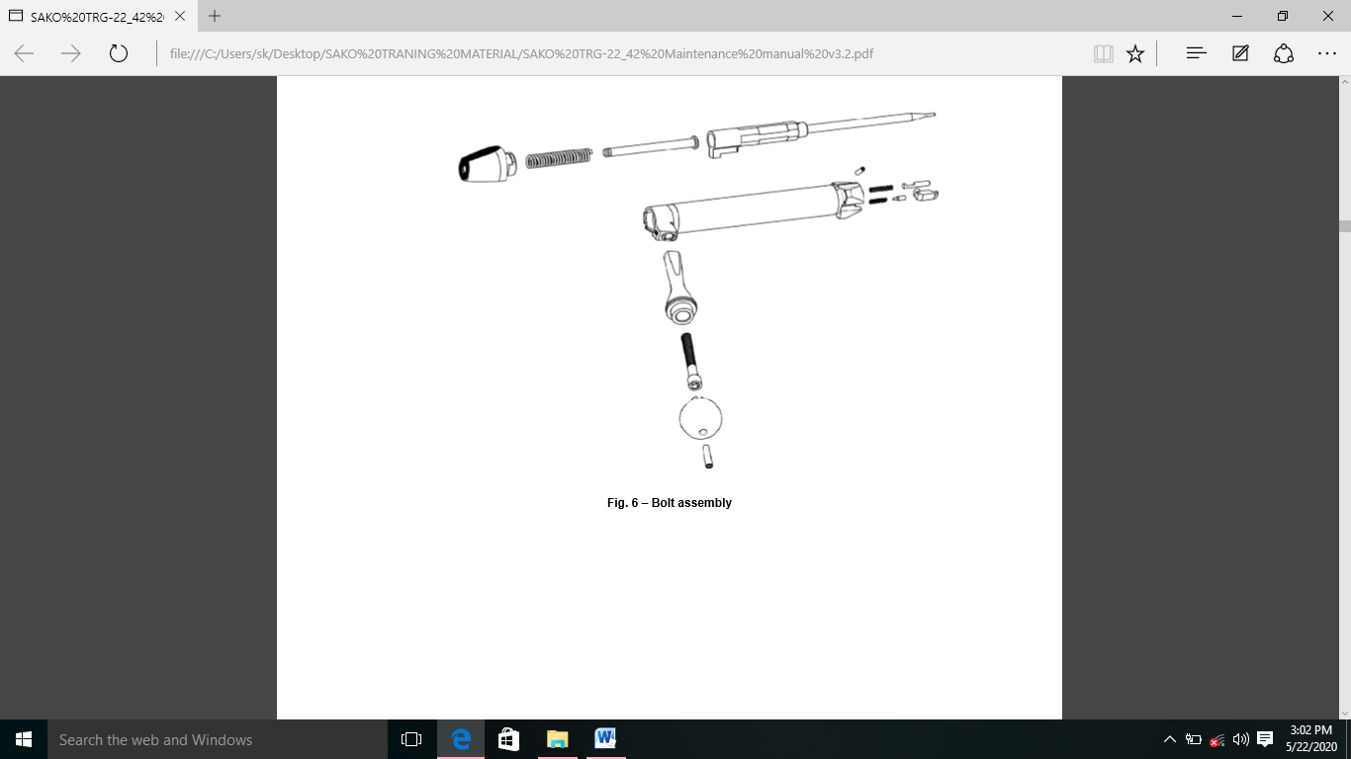(ix) Firing pin assembly ke sabse pichle hisse mein ek cocking indicator hota hai, ek lal rang ka khaancha jise Bolt shroud ke beech mein hole ke madhyam se dekha jaa sakta hai.

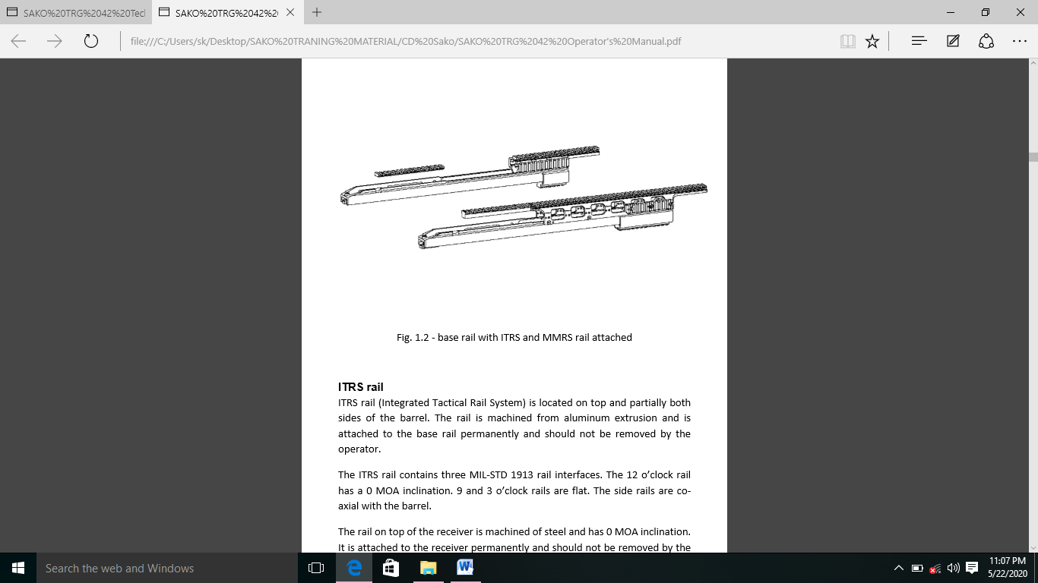c) **Base Rails and ITRS or MMRS Rail.** Base rail aluminium extrusion se banaya gaya hai. Base rail ek Rifle ke daanche ke roop mein karya karta hai, jisme barreled action, fore end, rear stock ya folding stock ka Anaya sabhi component judhe hote hain. Base rail ke sabse upar military std 1913 MMRS rail ke liye ek jagah hai. Jis par rail ko sthayi roop se jodha gaya hai.

(i) **ITRS Rail**

(aa) (Integrated Tactical Rail System) barrel ke upar or dono taraf sthit hai. Rail ko aluminium extrusion se tayar kiya jata hai. Or base rail se sthayi roop se judha hota hai. Or operator dawara ise hataya nahi jana chahiye.

(ab) ITRS rail mein 3 Mil std 1913 rail interface hai. 12 bje ki rail mein 0 MOA jhukav hai, 9 or 3 bje rail parallel hai. Sight rail barrel ke sath ek ki rekha mein hain.

(ac) Receiver ke sabse upar rail steel ki bani hui hai. Or isme 0 MOA jhukav hai. Yeh receiver ke sathayi roop mein judha hota hai or operator dawara ise hataya nahi jana chahiye.

(ii) **MMRS Rail**

(aa) (Monolithic Modular Rail System) barrel ke top or dono taraf sthit hai. Rail ko aluminium extrusion se tayar kiya jata hai or base rail se sthayi roop se judha hota hai. Or operator se ise hataya nahi jana chahiye.

(ab) MMRS mein mil std 1913 rail interface hai 12 bje ki rail mein 30 MOA jhukav hota hai . 9 or 3 bje ki rail plane hoti hai or puri MMRS rail ko hataye bina badli kiya ja sakta hai. Side rail barrel ke sath attach hain. MMRS rail ke nirman ke charon or ramp barrel ke charon or ek heat shield ke roop mein karya karta hai jo operator ke hathon ko garam sataho ke samapark se bachata hai.

(d) **Rear Stock (Folding Type)**

(i) Rear stock aluminium or polyurethane se bana hai. Folding stock ke upar hinge section ko body rail se joda jata hai.

(ii) Folding stock ko fastening piece or screw ka upyog karke base rail par bandha jata hai.

(iii) Folding stock haathiyar ke pichle hisse ko modne ki kshamta deta hai jisse ise asani se le jaaya jaa sakta hai. Folding stock ko firer ko seemit sathano mein hathiyar le jaane ke liye adhik jagah dene ke liye design kiya gaya hai.

(iv) Folding stock mein aluminium frame ke sath piston grip or frame ke corner se judhe polyurethane grip panel hota hai.

(v) Folding stock symendrical hai isliye daye ya baye hand ke shooter dwara operate kiya jata hai.

(vi) Folding stock ke nichle hisse se behtar target acquisition aur long term surveillance ke liyewpn ko stable karne ke liye real monopod hai.

(vii) Adjustable cheek rest folding stock ke upar bhag par sthit hai, cheek pad ko asani se firer ke hisab se rest dene ke liye bina tools ke vertically adjust kiya gaya hai.

(viii) Folding stock ke pichle hisse mein ek adjustable recoil pad assembly hoti hai. Recoil pad ko upari ko aage piche ki taraf adjust kar sakte hain.or sath mein wahan rear sling swivel ke liye bhi sathan hai.

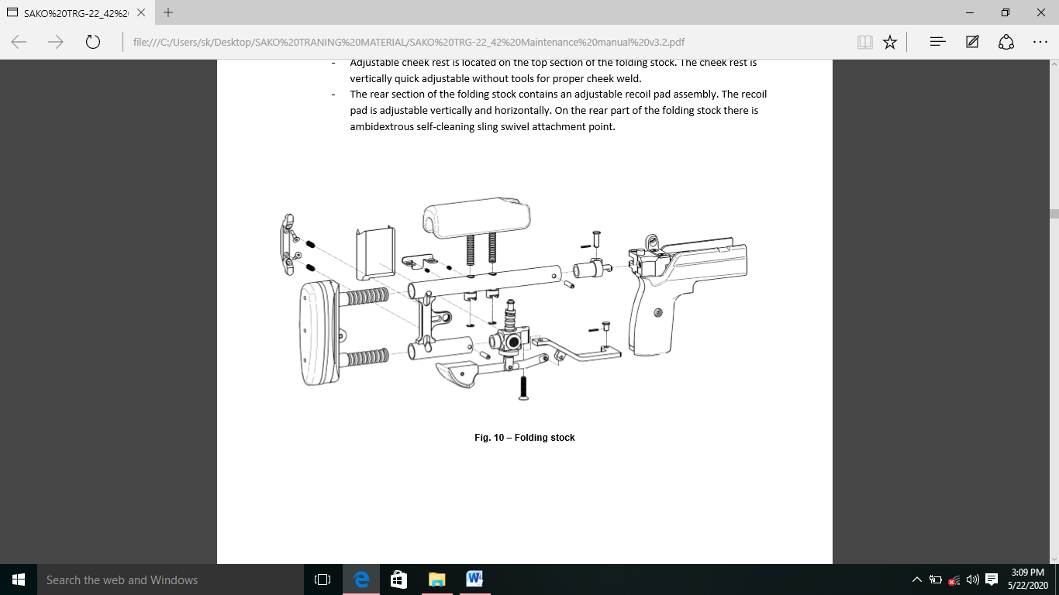

(f) **Rear Stock (Fixed Type)**

(i) Fixed stock polyurethane se bana hai. Or ek aluminium extrusion se bana hai.

(ii) Fastening piece aur screw ka istemal karke base rail par sthit stock ko bandha jata hai.

(iii) Fixed stock is symmetrical jo baayen or dayeen hath ke firer dwara operater kiya jaa sakta hai.

(iv) Fixed stock ki nichli satah par free hand grip ke liye shoulder hota hai.

(v) Fixed stock ki upari satah ko adjustable check piece ko jodne ke liye design kiya gaya hai, cheek piece ko allen screw ko or nut ko cheek piece rail se joda jata hai. Jise screw dwara fixed stock se bandha gaya hai. Cheek piece ki unchai ko spacer ka upyog karke ek saman kiya jaa sakta hai, jiske liye fastening screw ko dheela karna padta hai. Fixed stock ke andar vekalpik peep sight ko dekhne ke liye upyukt jagah hai.

(vi) Fixed stock ki sabse pichli satah ko adjustable recoil pad ko jodne ke liye design kiya gaya hai. Recoil pad base ko allen screw or ek nut ke sath ek rail se bandha jata hai. Jise screw ka upyog karke apne sathan par bandha gaya hai. Allen screw mein ek vishesh washer hota hai jo vertical axis ke sath recoil pad ko modne ki anumati deta hai. Iske alawa allen screw mein ek or ring hai jo purn recoil pad assembly ko hatane ke mamle mein nishchit stock ke andar girne se rokta hai. Recoil pad ko vertically face se adjust kiya jaa sakta hai.

(vii) Recoil pad 2 allen screw or nuts ka upyog karke recoil pad base par bandha jata hai. Recoil pad or uske base ke beech spacers dal kar pull ki lambai ko adjust kiya jaa sakta hai us sthiti mein bandhan lambe samay tak badlna awashyak ho sakta hai. Recoil pad ke sath adjust kiya jaa sakta hai. Fastening screw ko loose karke recoil pad ko sideways or dursi or bhi adjust kiya jaa sakta hai.

(viii) Fixed stock ke dono kinaron par clip hook ke liye jagah hai.

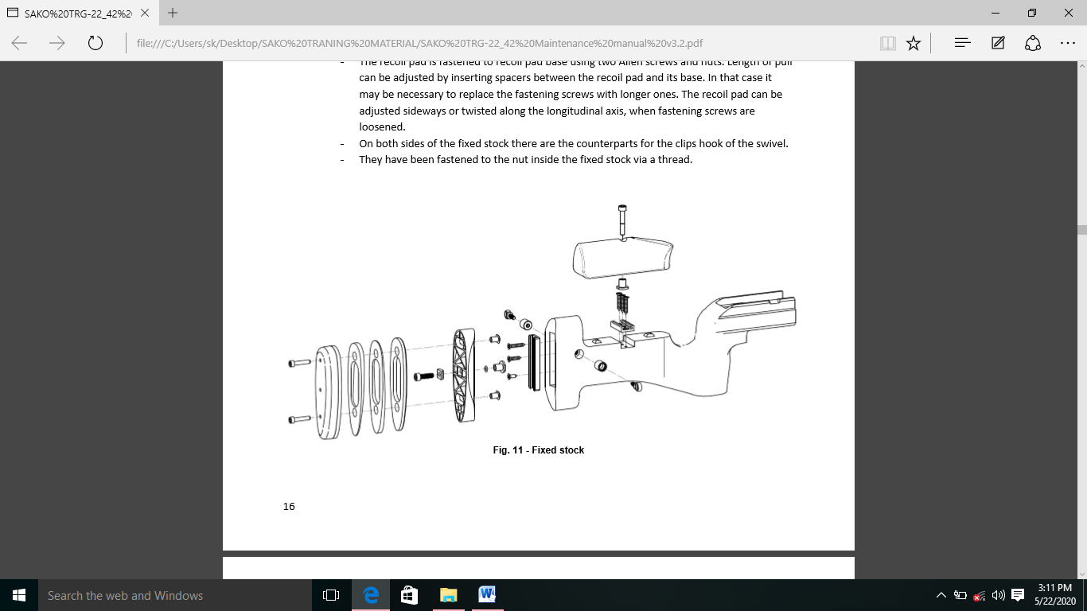(ix) Unhe ek thread ke madhyam se unhe fixed stock ke andar tight kiya gaya hai.

(g) **Fore-End**

(i) Fore-end polyurethane rubber ka bana hota hai. Ise allen screw or fastening piece ki madad se base rail par jodha jaata hai.

(ii) Nichli satah par ke fore end par koi bhi accessory jodne ke liye ek rail hoti hai. Rail ko chaar screw ke madhyam se joda jaata hai.

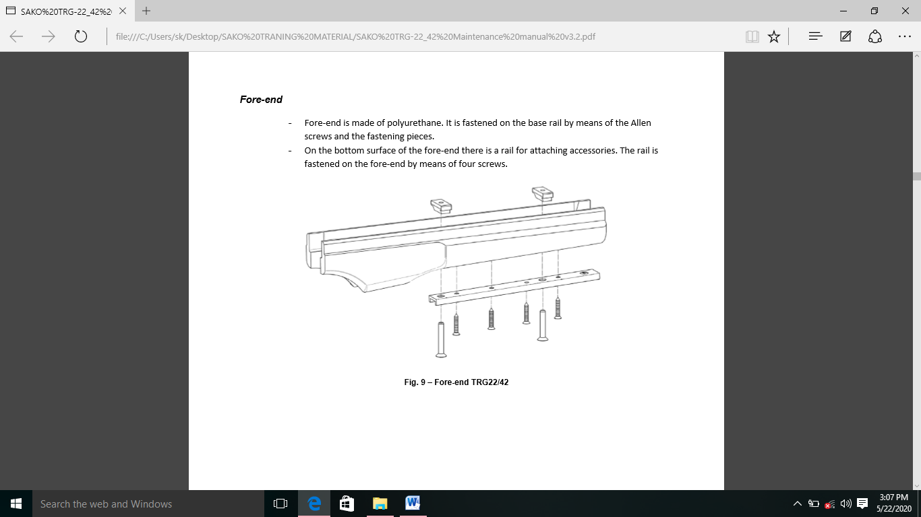

(h) **Trigger Mechanism**

(i) Trigger mech ek alag unit hai. Ise M-6 allen screw ki madad se receiver ke nichle hisse mein joda gaya hai.

(ii) Teen pin trigger guard ko trigger mech ki housing se jodte hain. Mag catch or uske spring ko trigger guard ke samne pivot ke sath joda gaya hai.

(iii) Trigger mech ko trigger guard ke sath Rifle se bina hathiyar ko alag kiye alag kiya jaa sakta hai.

(iv) Trigger mech mein ek trigger, ek connecting lever or ek sear hota hai. Trigger mech trigger foot ke end mein ek screw ki madad se joda jata hai jo trigger body ke sath permanently attach hai.

(v) Trigger mech mein 2 pull hain. Pehle trigger pull ke dauran trigger ko squeeze kiya jaata hai or pehla pull mein spring ko tanav milta hai. Jab trigger connecting lever ki pichli satah se takrata hai to trigger pull bad jaata hai. trigger ko dusre pull hasil karne mein jorr lagta hai.

(vi) Connecting lever ka upari bhag sear ko neeche ki or dabata hai. Jiske baad Firing pin spring mein force ki sahayta se aage badhta hai or primer se takrata hai.

(vii) Pehle pull spring ke tanav or total trigger pull ko upyukt adjustment ki sahayta se adjust kiya jaa sakta hai.

(viii) Vertical and horizontal trigger ko adjust karne ke liye fastening screw ki madad se kiya jaata hai.

(ix) Safety mech mein locking Bolt, Safety lever, or Safety lever extension hota hai. Jo trigger guard tak faile hote hain orjiske jariye Safety function ko control kiya jata hai.

(x) Locking Bolt, Bolt ko uski bandh sthiti mein block kar deta hai or usi samay cocking piece ko aage badhne se rokta hai. Taki Firing pin primer tak pahunch sake. Locking Bolt ke neeche ek rubber buffer hota hai. Jo locking Bolt ke vertical movement ke karan audible noise ko kam karta hai.

(xi) Safety lever connecting lever ko lock kar deta hai taki yeh sear ko bahar na nikal sake. Safety lever mein 2 phase ka spring hota hai jo kewal 2 Safety lever ki posn ko jahir karta hai ON/OFF.

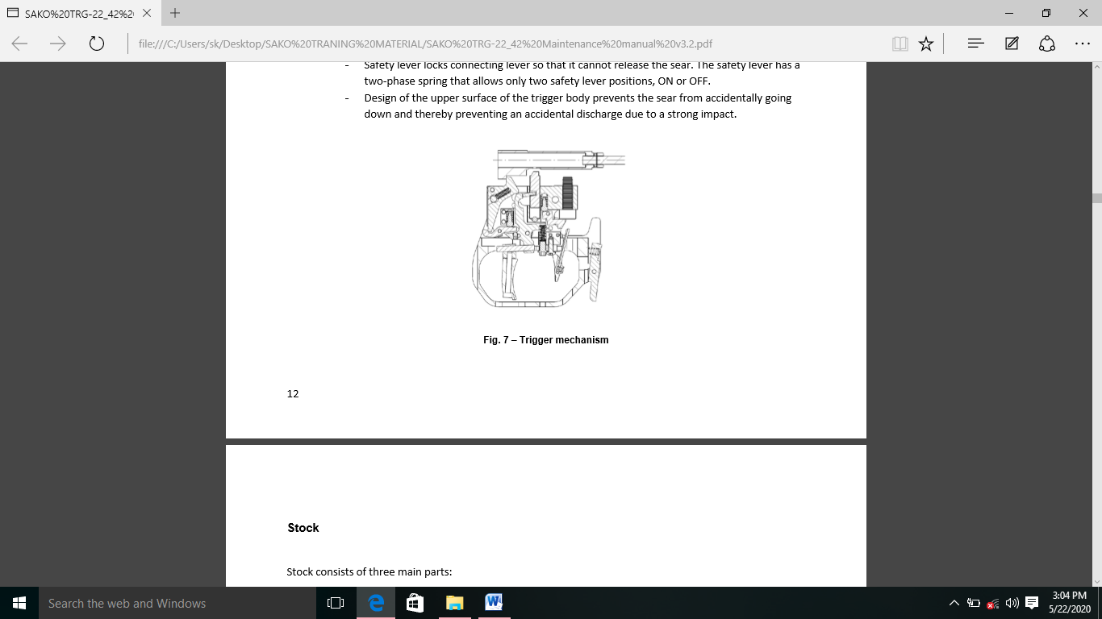(xi) Trigger body ki upari satah ka design galti se sear ko neeche jaane se rokta hai or is tarah ek majboot prabhab ke karan accidental discharge ko rokta hai.

(g) **Magazine**

(i) Trg 42 ki magazine ek centre feeding box magazine hai . Magazine box ek steel plate se bana hai. Magazine box ka upari bhaag feeding lips banata hai jo magazine mein catridge rakhte hain or sath hhi feeding ke dauran unhe guide karte hain. Magazine box ke samne upari hissa isliye banaya gaya hai taki magazine follower or mag box se bahr aane se roka jaa sake. Magazine box ke peeche ki diwar par ek opening hai jo trigger guard mein sthit ek catch ke sath karya karta hai. Magazine ke pichle nichle konon par riveted studs hain, jo magazine hatane mein madad karte hain.

(ii) Catridge follower ko is tarah design kiya gaya hai ki yeh chambering ke dauran catridge ko support karta hai. Chambering ke dauran cartridge ka front notch follower mag ke last cartridge ko support karta hai. Notch ek support ke roop mein bhi kaam karta hai jab single cartridge ko ejection port ke madhyam se chamber mein rakha jata hai. Mag box ke ander ek covering plate hote hai jo mag follower spring ko bhi guide karte hai.

(iii) Magazine catch or uske spring ko trigger guard ke samne pin se joda jata hai. Bhari hui magazine dalte samay ise achi tarah se magazine mein seedha dhakelein or mag ko tab tak dabaye jab tak mag ise apni posn mein na pakad le. Mag ko alag karte samay mag ko anguthe se pakdein or mag ke pichle or neeche ke konon par sthit detaching stud ki sahayta se mag ko Rifle se bahar nikalein.

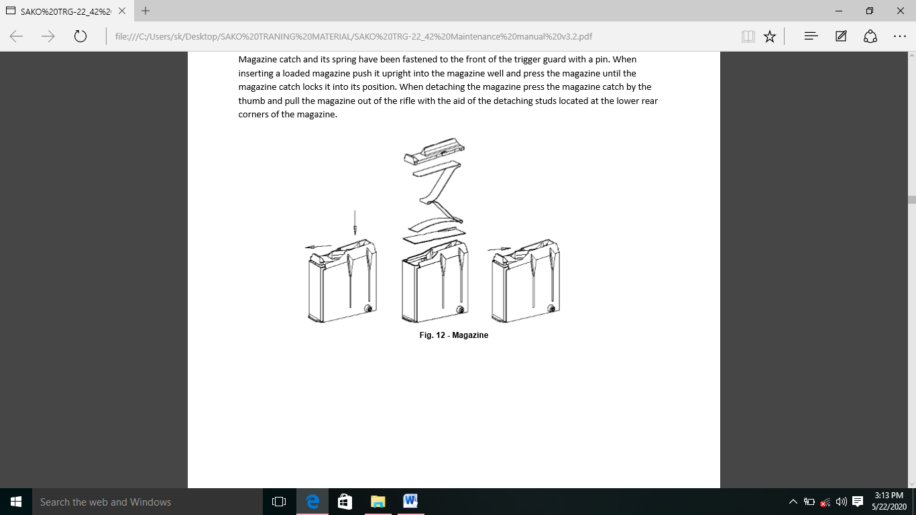

(h) **Base Rail and Picatinny Rails**

(i) Base rail ka nirman aluminium extrusion se kiya jata hai. Yeh ek Rifle kedanche ke roop mein karya karta hai. Jismein barrel receiver, fore end or piche ke stock ke anay sabhi component ko joda jata hai.

(ii) Base rail ke pichle bhag mein pichle stock ko jodne ke liye ek hole hota hai. Uske samne trigger mech, mag or barreled receiver ke fastening screw ke liye jagah hai. Mag ke front guide ko mag ke samne achi tarah se set screw ke sath joda jata hai.

(iii) Base rail ki top surface ke beech mein recoil lug ke liye ek slot hota hai. Steel recoil lug ko comprestion joint ke dawara base rail mein sthayi roop se joda gaya hai.

(iv) Front screw ek sath ITRS rail system or base rail ki steel reinforcement plate ko jodta hai. Steel reinforcement plate mein opening ki samne ki satah bipod lutch ke roop mein karya karta hai.

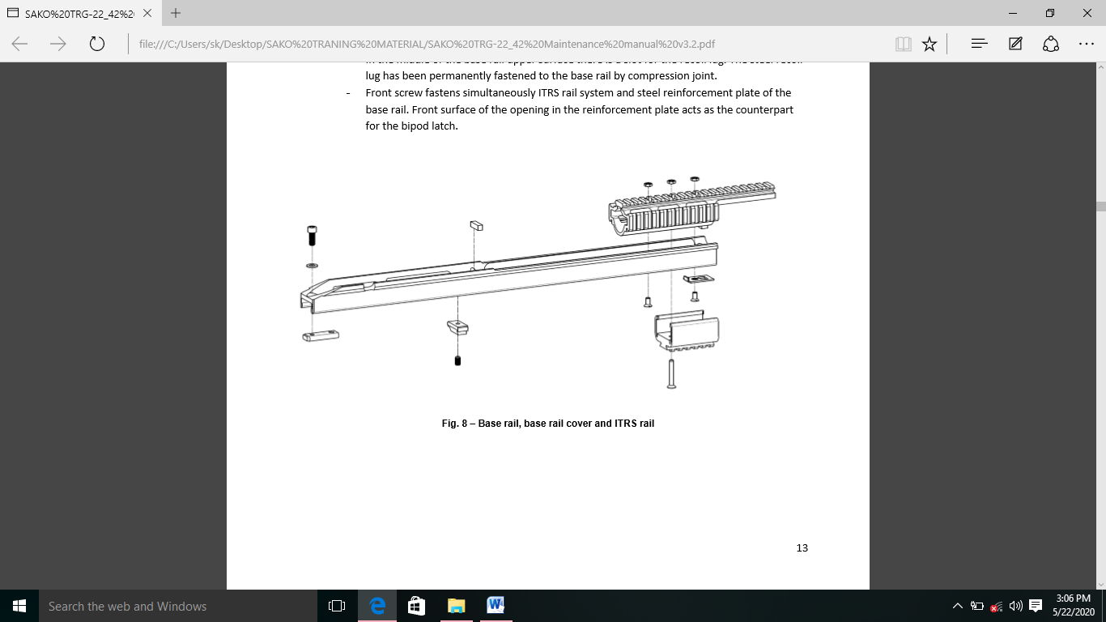

(j) **Fore-End and Base Rail Cover**

(i) Sako TRG42/22 ka fore-end polyurethane se banaya gaya hai. Yeh hex screw or fastening screw ke sath base rail ki nichli satah se juda hua hai.

(ii) Base rail cover base rail ke samne wale bhag ke khule bhag ke samne sthit hai.

(iii) TRG42/22 ke beech ka antar sirf mag ke akaar ka hai.

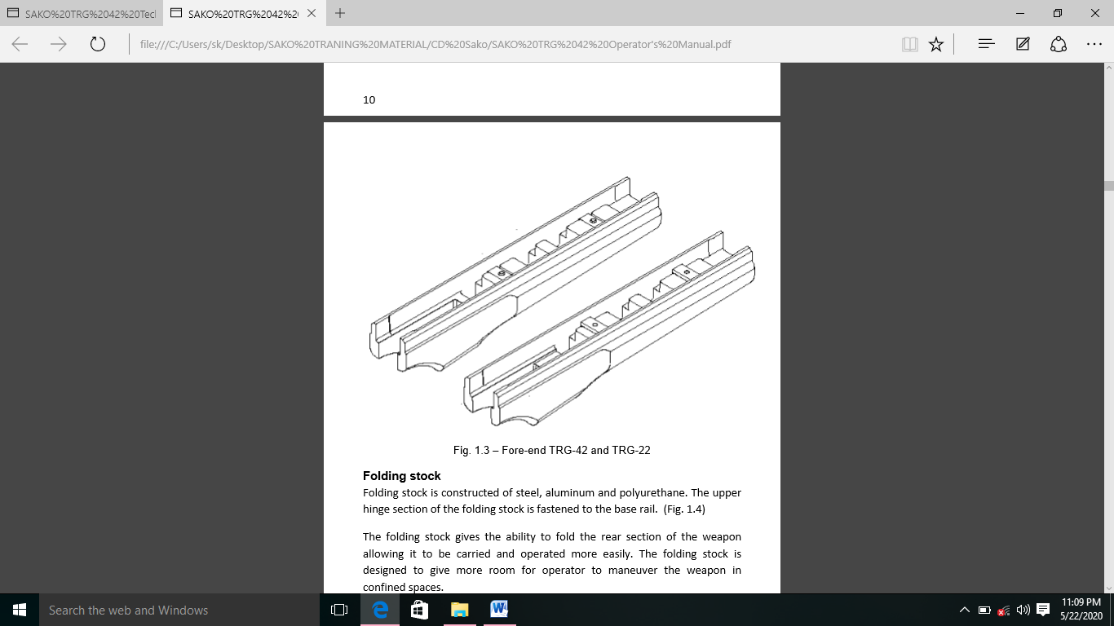

5. **Field Stripping and Adjustments**

**Kholna/Jodna**

1. **Bolt ko kholna :-**

(i) **Bolt ko Receiver se kholna :-** Receiver ke dahine or sathit Bolt stop ko dabakar receiver ko Bolt se alag kareinin or bahar nikalein.

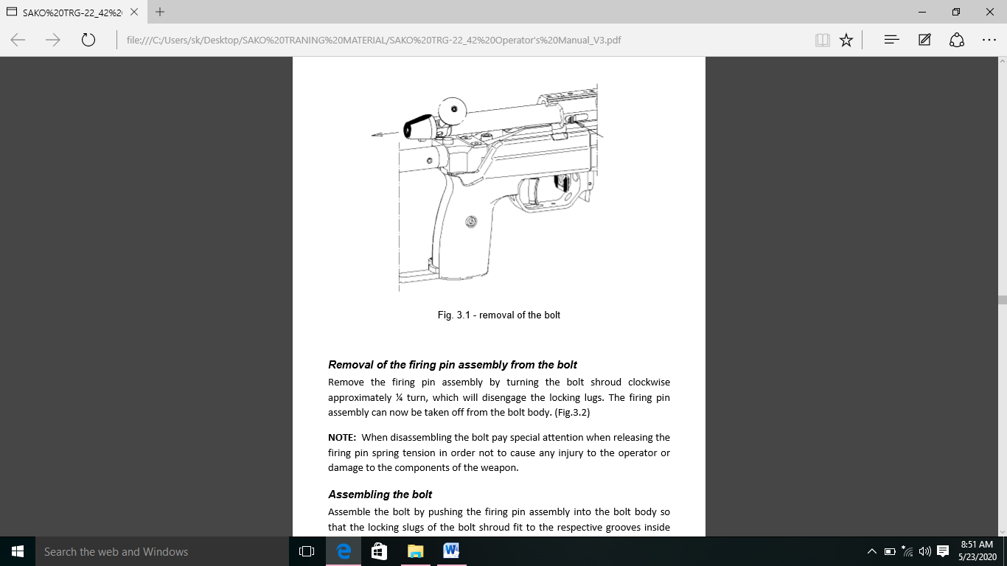

(ii) **Firing Pin Assembly ko Bolt se alag karna :-** Bolt shroud ko laghbhab ¼ ghumakar Firing pin assembly ko kholenin, jisse locking lug alag ho jayenge. Firing pin assembly ko ab Bolt body se hataya jaa sakta hai.

**Note: -** Bolt ko alag karte samay Firing pin spring tension ko chodte hue vishesh dhayan dein taki operator ko koi chot ya hathiyar ke kisi hisse ko koi uksan na ho.

**Assembling the Bolt**

(i) Firing pin assembly ko Bolt body mein Dhakka dekar Bolt ko jodhe taki Bolt Bolt slugs ke locking slug Bolt body ke ander grooves mein fit hojaye. Cooking piece ko Bolt handle ke opposite hona chhaiye.

(ii) Bolt shroud ko Bolt dissembling tool ki sahayata se push Karein taki Bolt shroud Bolt ke pichle hissa per tika rahen.

(iii) Bold shroud ko counter clockwise ghumayen jab tak ki cocking piece ka follower Bolt body per resting group ke sath align na hojaye. Bolt ab utha huwa hai or isse receiver mein wapas dala ja shakta hai.

**Note: -** Bolt ko assemble karte samaye conform Karein ki Bolt shroud ko palat na den ta ki cocking ka piece aage (uncock)position mein gir jayen.Yadi aissa hota hai toh covking piece or resting group ko align karne ke liye Bolt slugs ko clockwise ghumayen.

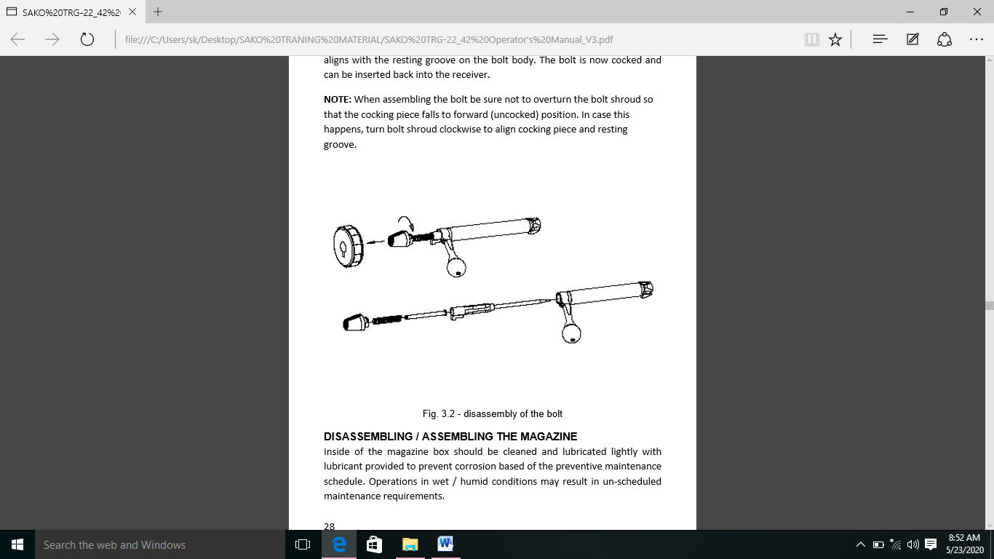

1. **Magazine ko Kholna aur Jodna** :-

(i) Mag box ke ander preventive maintainance schedule ke adhar per jung ko rokne ke liye pradan kiye gaye lubricant ke ke sath halke dhang se saaf aur lubricanion kiya jana chiya. Gili naam sthiti me sanchal ke paranam savroop nirdharit arak rakav ki jarurat ho sakti hai.

(ii) Mag ko alag karne ka liya cartridge followers ko piche se neeche ki aur dhakele aur mag box ko mag spring ke sath nikalne ka liya ise aghe ki aur slide karein. Mag ki assembly revised order se karein.

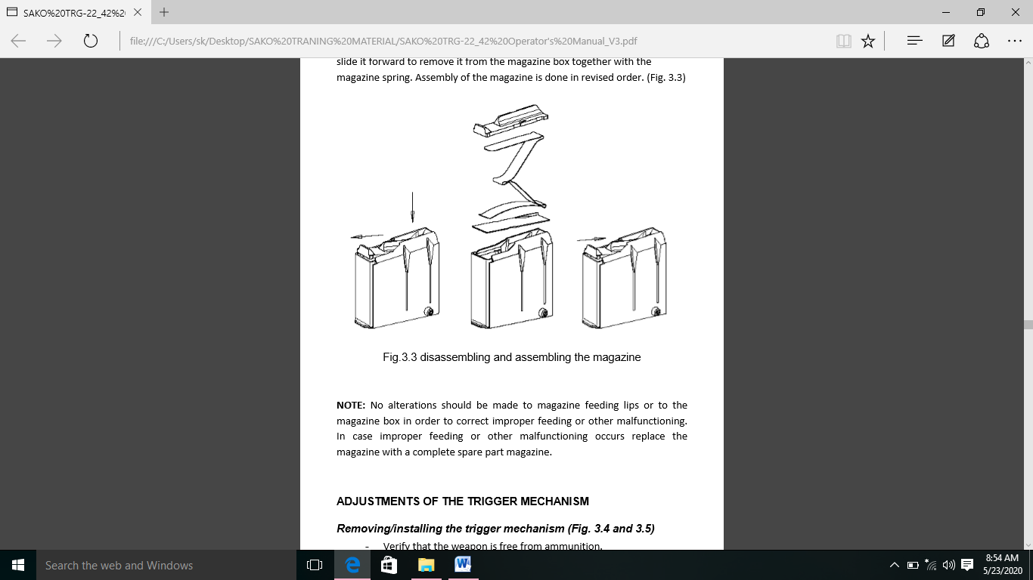**Note: -** Inproper feeding ya anya khrabi ko door karne ke liye mag feeding lips or mag box me koi badlav nahi kiya jana chiya. Inproper feeding ua anya khrabi hone hone ke stithi me mag ko complete spare parts mag se badal de.

**Adjustments of the Trigger Mechanism**

(c) **Trigger Mech ka Kholna aur Jodna**

(i) Bolt or mag ko hata de.

(ii) Safety ko aghe ki stithi me dhakel kar Safety ko band karein.

(iii) Trigger ko kicho or trigger gard me slot ki madad se 5mm hax key dalein.

(iv) 5mm hex key ka use karke trigger mech ko fastening screw ko kholen.

(v) Trigger mech ko rif se neeche ki aur kheenchein.

(vi) Installation ki karwai reverse order me ki jati hai.

(vii) Trigger mech ke fastening screw ko dheela karna.

(viii) Trigger mech ko remove karein.

**Note: -** Fastening screw ko final tight karne se pahle trigger mech ko ghuma kar insure karein ki yah receiver par apne slot me aghe or piche dono taraf saman roop se fit bethta hai.

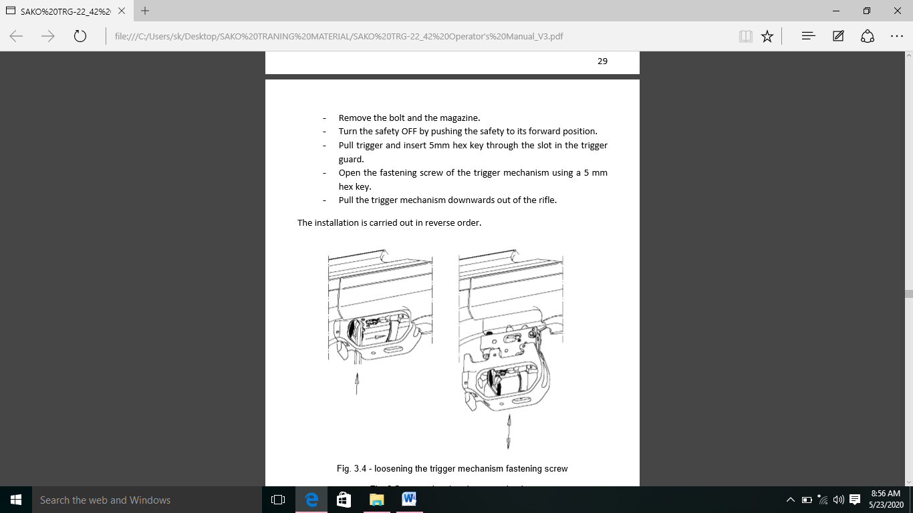

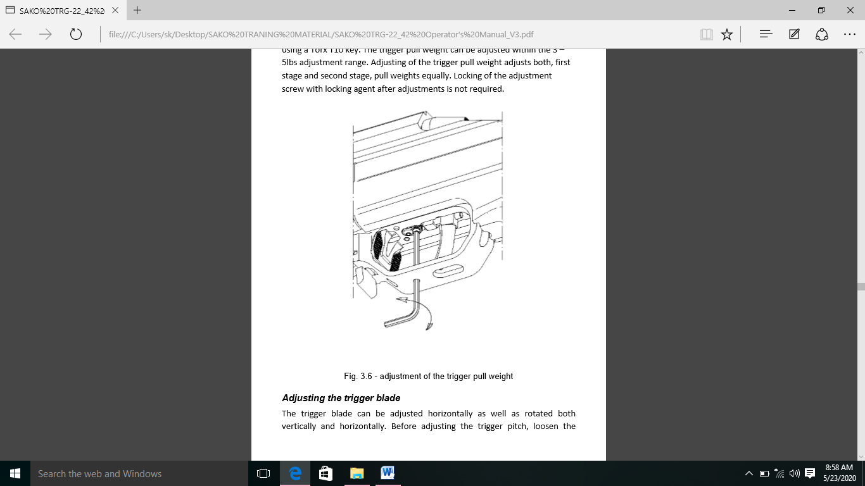(d) **Trigger Pull ko adjust karna.** Jab adjustment screw ko trox T10 hex ka upyog karke clock wise ghumaya jata hai to trigger pull badh jayga. Triggerpull ka weight ko 3-5 lbs par adjust range tak kiya ja sakta. Triggerpull weight a adjustment pahla stage or dusra stage dono ko adjust karta hai, weight ko barabar roop se kichta hai. Adjustment ka baad adjustment screw ko locking agent ke sath lock karne ki awaskta nahi hai.

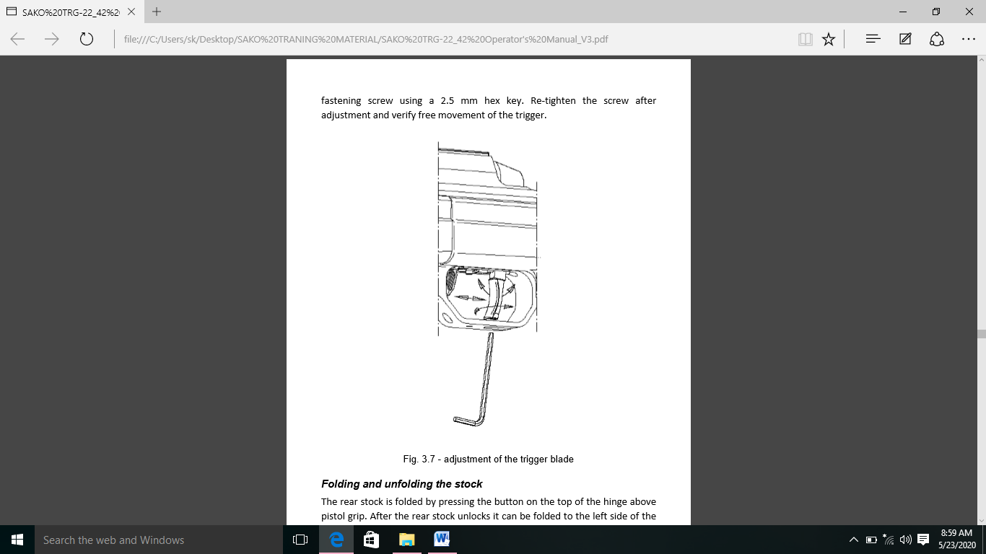(e) **Trigger Blade ko adjust karna.** Trigger blade ko horizontally roop se adust kiya ja sakta hai or sath hi horizontally or vertically roop se ghumaya ja ssakta hai. trigger pitch ko adjust karne se pahle, 2.5 mm hex key ka upyog karke fastening screw ko dheela karein. Adjustment ke baad screw ko fir se tight karein or trigger ke free movement ko verify karein.

(f) **Butt Stock ko Fold aur Unfold karna.** Pistol grip ke upper hinge ke top per button daba kar rear stock ko fold kiya jata hai. Rear stock ko unlock hone ke baad ise wpn ke left or tabtak fold kiya ja sakta hai jabtak ki yeh locking button dwara securely fold hui sthiti me lock na hojaye. Piston grip ke upper hinge ke top per locking button ko daba kar rear ke stock ko uski folded stithi se khola jata hai. Rear stock unlock hone ke baad ise wpn ke parallel tabtak khola ja sakta hai jab tak ki yeh locking button dwara open posn me suraksit lock na hojaye.

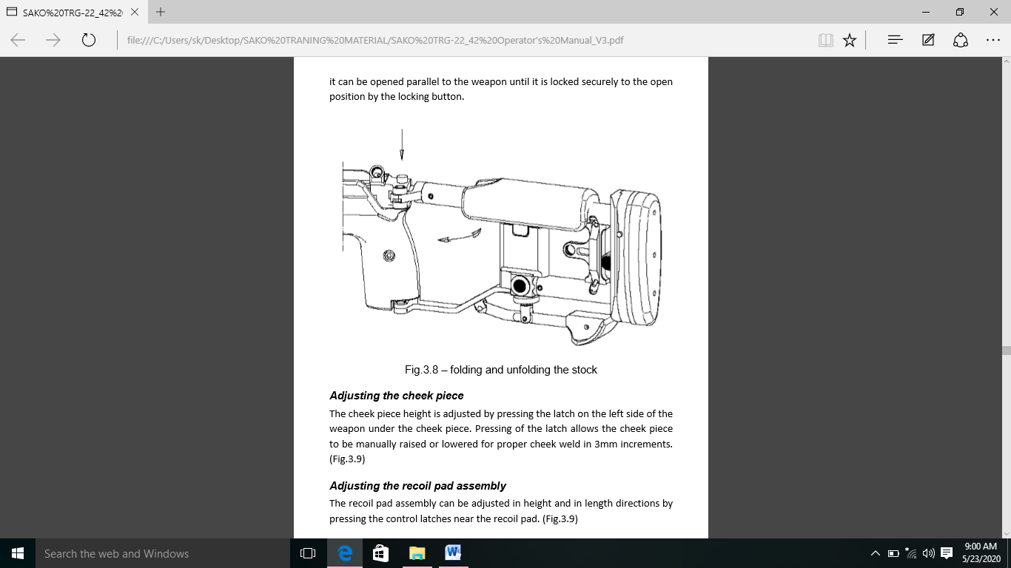

(i) **Cheek Piece ko Adjust karna.** Cheek piece ke under wpn ke left side

ki letch ko daba kar cheek piece ki hight ko adjust kiya jata hai. Latch ko dabane se cheek piece ko 3mm ki increment me proper cheek weld ke liya mannualy upper ya neeche kiya ja sakta.

(ii) **Recoil Pad Assembly ko Adjust karna.** Recoil pad assembly ko recoil ke pas ctrl edge ko daba kar hight or length ki direction me adjustment kiya ja sakta hai. Recoil pad ki hight ko recoil pad ke samne left or samne ki posn me push button ko daba kar or recoil pad assembly ko upper or neeche slide karke adjust kiya jata hai. Button ko release karne per recoil pad assembly positively us posn me lock hojayegi jaha adjustment kiya gaya tha.

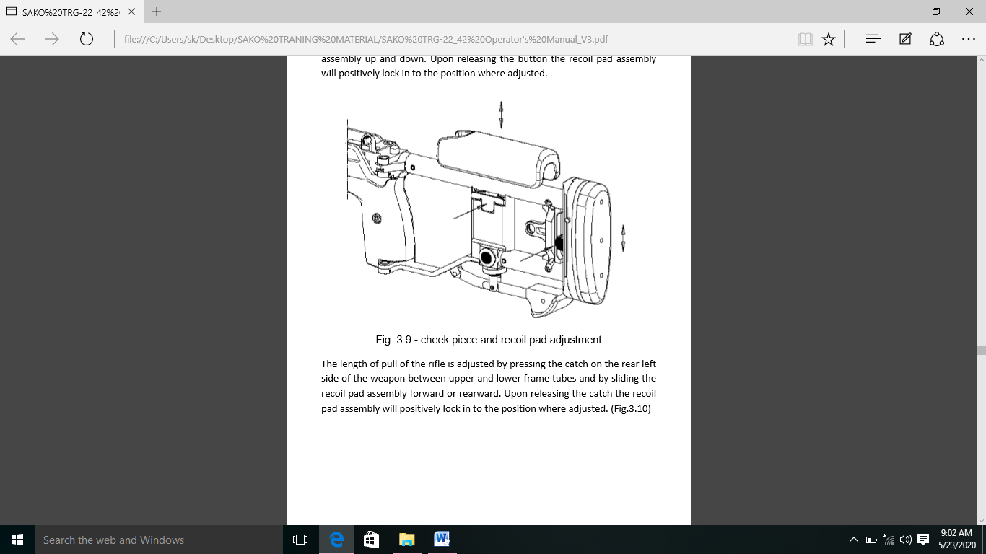

upper or lower frame tubes ke bich left aur catch ko daba kar recoil pad assembly ko aghe or piche ki aur slide karke rif ke neeche ki lambai ko adjust kiya jata hai. Catch chodne par recoil pad assembly nischit roop se us jagah me lock hojaygi jaha adjust kiya gaya tha.

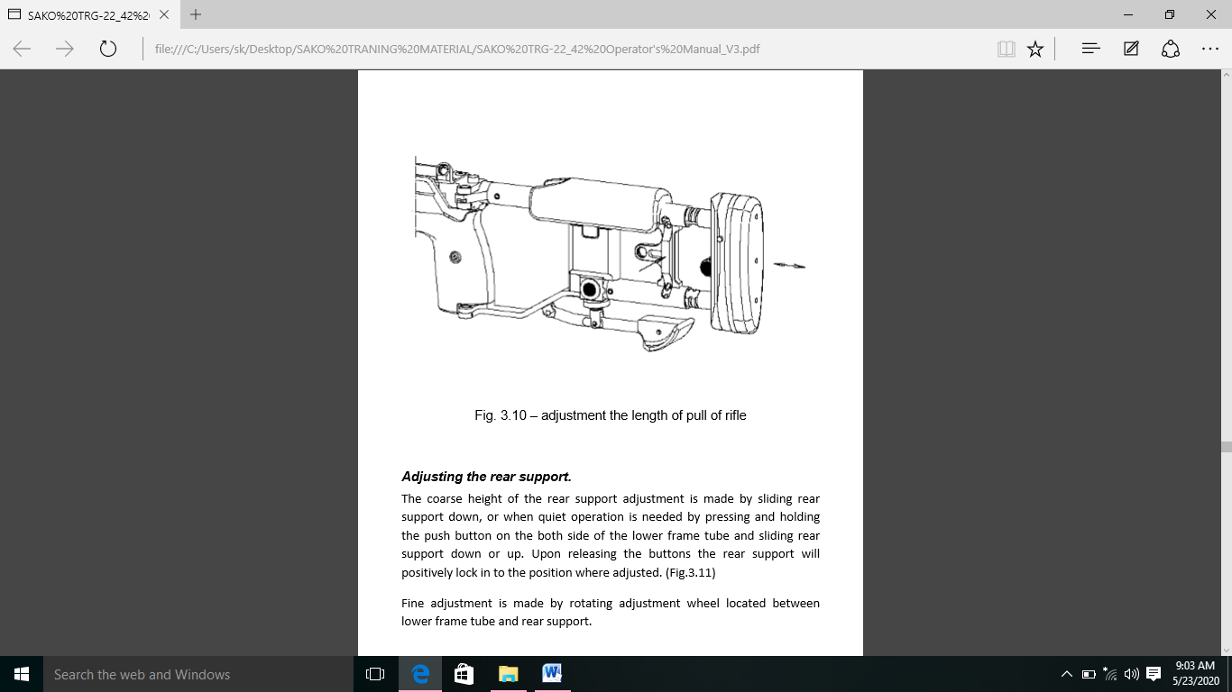

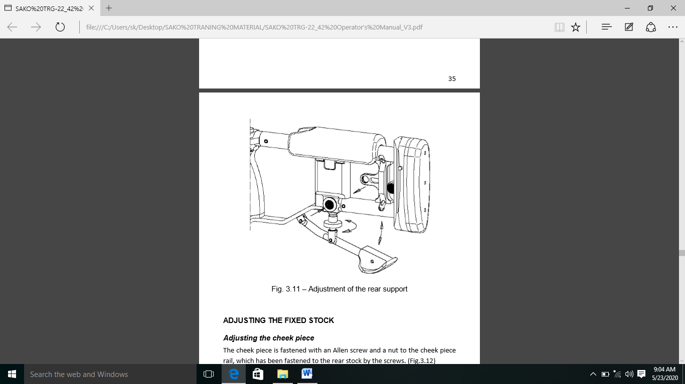(iii) **Rear Support ko Adjust karna.** Rear support adjustment ki coarse height ko rear support ke neeche slide karke banaya jata hai, ya jab nichle frame tube ke dono taraf push button ko dabakar or piche ki support ko neeche ya piche slide karke quite operation ki jaruat hoti hai. Button release karne per pichla support positively roop se sahi posn me lock hojayga. Lower frame tube or rear support ke bich rotating adjustment wheel ko ghuma kar fine adjustment kiya jata hai.

(g) **Fixed Stock ko Adjust karna**

(i) **Cheek Piece ko Adjust karna**

(aa) Cheek piece ko allen screw se or ek nut ko cheek piece rail se jodha jata hai, jise screw dawara rear stock mein bandha gaya hai.

(ab) Cheek piece ki height spacer ka upyog karke adjust ki jaa sakti hai. Aise karne ke liye adjusting screw ko ek lambe samay se badla jana chaihiye.

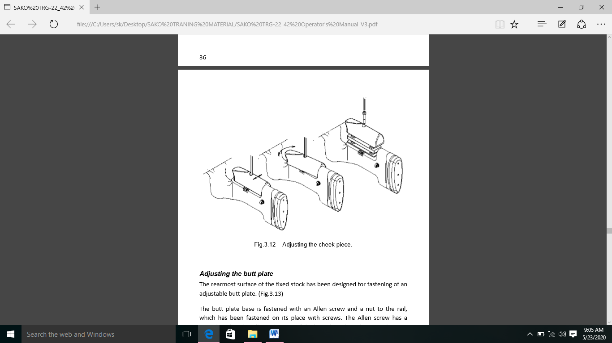(ac) Cheek piece ka vintage hortizontal or vertical dono tarah se adjust kiya jaa sakta haii jab adjusting screw ko phle dheela kar diya ho. Rear stock ke andar optional auxillary peep sight dekhne le liye upyukt jagah hai.

(ii) **Butt Plate ko Adjust karna**

(aa) Fix stock ki sabse pichli satah ko ek adjustable butt plate ke jodne ke liye design kiya gaya hai.

(ab) Butt plate base ko allen screw or rail ke liye ek nut ke sath joda jata hai, jiske screw ke sath jodha jata hai. Allen screw mein ek special washer hota hai jo butt plate ko vertical axis ke sath fold karne ki anumati deta hai.

(ac) Iske alawa allen screw mein ek or ring hai jo full butt plate assembly ko hatane ke mamle mein butt screw ko stock ke andar girne se rokta hai.

(ad) Butt plate ko vertical roop se adjust kiya jaa sakta hai jab centre mein fastening screw ko dheela kiya gaya ho.

(ae) Allen screw or nut ka upyog karke butt plate ko butt plate base se jodha jata hai. Pull ki lambai ko butt plate or uske base ke beech spacer dal kar adjust kiya jaa sakta hai. Us sthiti mein fastening screw ko lambe samay tak badalna avayashak ho sakta hai. Extra spacer or lambe screw standard supply mein shamil nahi hai.

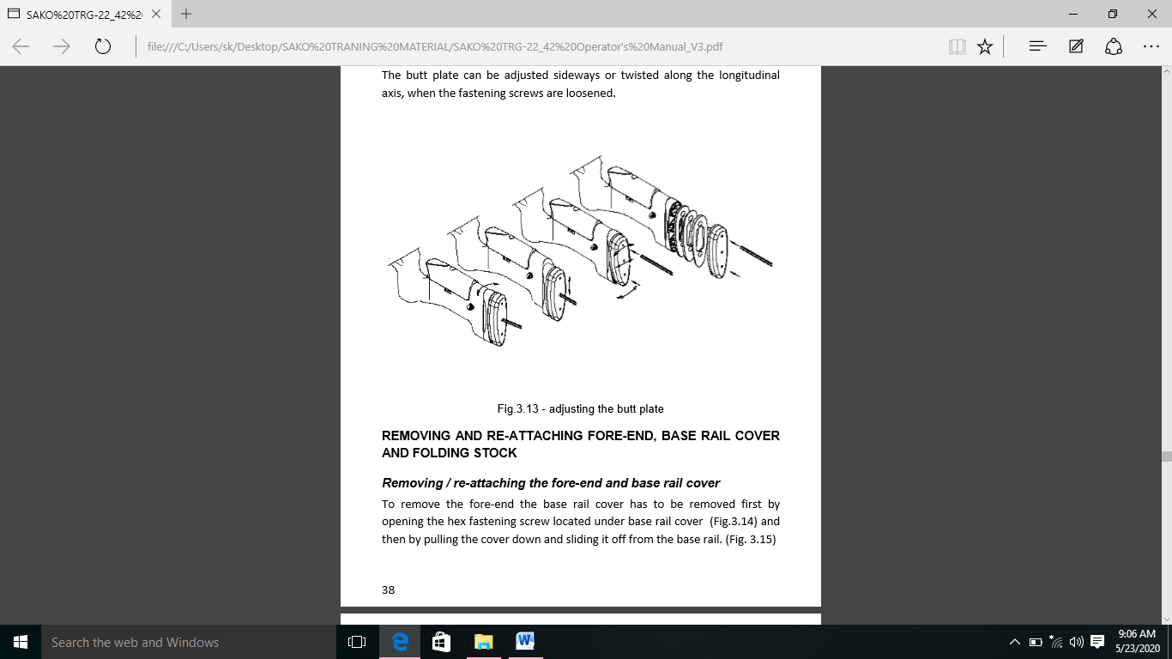(af) Butt plate ko bagal mein adjust kiya jaa sakta hai ya longitudinal axis ke sath twist kiya jaa sakta hai jab fastening screw dheela ho jata hai.

(h) **Fore-End ko Kolna aur Jodna, Base Rail Cover and Folding Stock**

(i) **Fore-End and Base Rail Cover ko Kholna aur Jodna :-** Front end ko hatane ke liye base rail cover ke neeche sthit hex fastening screw ko kholkar or fir cover ko neeche kheenchkar base rail se hatakar base rail cover ko hatana hoga. Iske baad foreend ke neeche sthit 2 hex fastening screw ko kholkar fore-end ko hata diya jata hai.

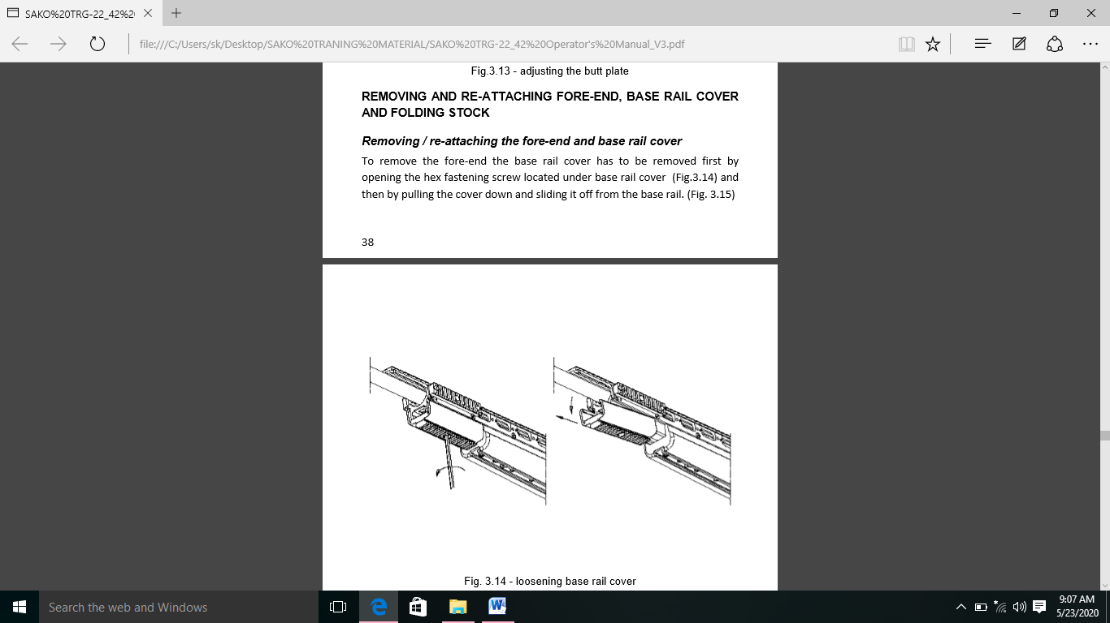

Screw ko kewal anshik roop se kholne ki avayasksatha hoti hai. Jab tak ki fore-end ko base rail se aage ki or khiskaya nahi jaa sakta.

Sliding se pehle fore-end ko neeche kheenchna. ¼ inch assist ko hatane mein madad karta hai. Base rail ke andar slot mein locking piece ko fore end mein slide karke fore ko fir se jodha jata hai. Locking screw ko prayapt roop se khola jana chahiye taki beh locking piece se bahar na nikle. Or base rail ke sath hastakshep na karein. Iske baad fore-end base rail par slide ho jata hai or piece ke stop ke contact mein aa jata hai. Fir diye gaye hex multitool ke sath locking scew ko tight kiya jata hai. Jab fore-end thk se base rail par rakha jata hai to locking screw ko base rail mein samandhit hole ke sath align karna chahiye iske bad base rail cover ko base rail mein slot ke sath locking piece ko align karke fir se jodha jata hai, base rail cover base rail par samne ke sieere ke samapark mein aa jata hai or screw tight ho jata hai. Base rail cover ke liye locking screw ko base rail mein samandhit hole ke sath bhi align karna chahiye.

**Note: -**  Base rail ke pichle seere or piche ke stock ke beech uchit samaprk banaye rakhne ke liye front end ko base rail par slide or lock karne se pehle rear stock ko hathiyar se jodha jana chahiye. Uchit prakriya ka palan karne mein following components ko dhayan dein.

(ii) **Fixed Rear Stock or Folding Stock ko Kholna aur Jodna :-** 2 locking screw (receiver ke piche ek piece top or piston grip or trigger guard ke beech ek piece bottom mein) kholkar rear stock kobase rail se hata diya jata hai. Or fir ise base rail se peeche ke or slide kar hata diya jata hai. Pichle stock mein samabandhit hole ke sath ise saaf karne ke liye top screw pura khola jana chahiye.

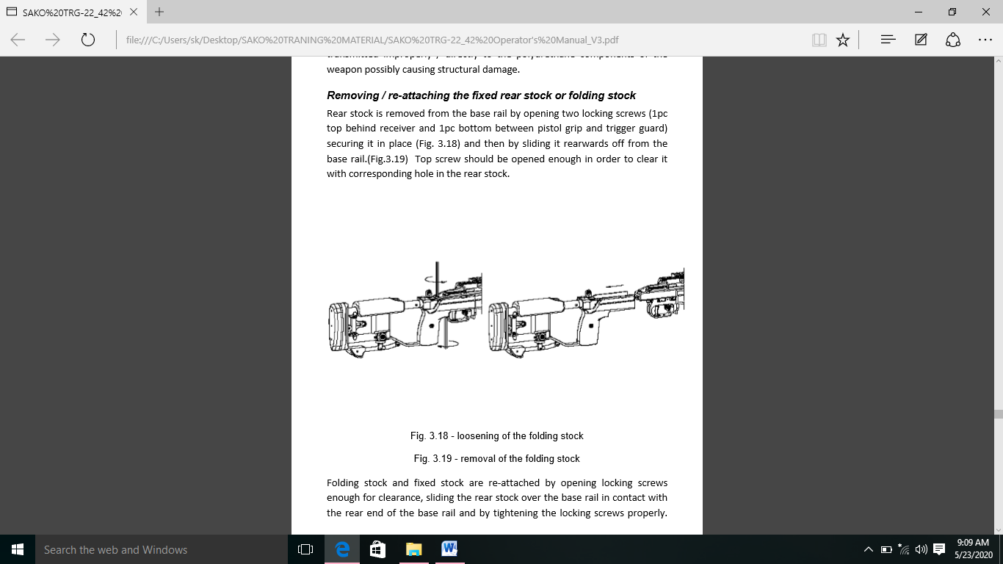

(iii) **Receiver Cover ke Screws ko Tight karna.** Receiver screws barrel wale receiver ko base rail se jodta hai. Base rail cover fore end or rear stock ko rail se hata diya jane par punah eccess kiya ja sakta hai. Preventive maintainance ke schedule ke adhar per receiver screw ki tightness ko samay samay per verify kiya jana chiya. Tight karne ke liye hex key multitool ka istemal kiya ja sakta hai. Incase receiver screw dheela ho gaya hai unhe hex multitool key ke sath tight karne ke liye fir se tight kiya jana chahiye. Testing se pata chala ha ki torque wrinch ka upyog avasyak nahi hai.

6. **Weapon Operation**

(a) Is wpn ko keval Bolt closed posn me Bolt se fire kiya ja sakta hai.

(b) Safety ki posn ke adhar per do possible operating mode hai.

(c) **Safety ON** – Jab Safety lever apne sabse pichle posn me hota hai to rif se fire nahi kiya ja sakta hai.

(d) **Safety OFF** – Jab Safety lever apne fore most posn me hota hai to rif fire ka liye taiyar hota hai.

(e) Rif ko cock karne ke liye Bolt ke handle ko uske upper kiya jata hai. Bolt ko uske sabse piche ki posn me laya jata hai or fir wapas lock posn me lota diya jata hai. Aghe badte samey Bolt head mag se sabse upper wala amn utata hai or use chamber karta hai iske sath hi Firing pin ko cock kiya jata hai or rif fire ka liye tyar ho jata hai.

(f) Ek extract kiya gaya fired case, Bolt ke btaya gaya tarike se operate karta hai. Bolt ko piche ki aur lejane ke samay cartridge case ko extract or eject kiya jata hai.

7. **Function Cycle**

(a) **Opening Bolt**

(i) Bolt ko kholne se Firing pin ko cock karne ke liye Firing pin ko vapas karne ke liye cocking slope ke karan banta hai.

(ii) Bolt locking lug receiver me locking surface ke piche se nikalta hai.

(iii) Extractor face rim ko pakad ka rakta hai.

(b) **Bolt in Rear**

(i) Jab Bolt piche ki aur hota hai to cartridge me upper ki aur partially Bolt ki line me uthne ke liye jagah hota hai.

(ii) Mag ke feed lips cartridge ko upper uthane se rokta hai.

(c) **Closing Bolt**

(i) Bolt ko band karne se cartridge aage ki aur push hota hai.

(ii) Magazine follower aur receiver par feed rim ke karan cartridge ka agla bhag chamber ki aur badh jata hai.

(iii) Jab magazine feed lips cartridge ko pakad kar nahi rakhta hai to yeh khud ko chamber ke sath align kar lete hai.

(d) **Bolt lagbhag Close**

(i) Jab cartridge chamber ke neeche phoch jata hai to Bolt chalna band kar deta hai.

(ii) Bolt ke handle ko neeche karne se Bolt ko aghe badhane ke liye majbur hona padta hai.

(iii) Ejector ko ander ki aur dhakela jata hai or ejector cartridge ke rim ke upper sawar hojata hai.

(iv) Locking lug receiver me locking surface ke piche mudne lagta hai.

(e) **Bolt Closed**

(i) Jab Bolt band hojata hai to ejector majbur hojata hai aur extractor cartridge ke rim ko pakad ke rakta hai.

(ii) Locking lugs receiver me locking surface ke piche hai.

(f) **Safety On**

(i) Jab sacfety on ho to Bolt locking pin Bolt body ko lock kardeta hai or Firing pin ko aghe jane se rokta hai.

(ii) Trigger movement ko Safety rokta hai.

(g) **Safety Off**

(i) Jab Safety off hoto Bolt locking pin Bolt ko lock nahi kar raha hai or firng pin ki chalk ko nahi rok sakta.

(ii) Trigger movement ko Safety nahi rokta hai.

(h) **Trigger not pulled**

(i) Jab trigger nahi kicha gaya Haiti hai to sear me bhot si engagement hoti hai.

(ii) Trigger body ka top part sear ko firng pin jari karne se rokta hai.

(j) **Trigger 1. Stage**

(i) Jaba trigger ko pull kiya jata hai lekin abhi bhi stage 1 me hota hai. Abhi bhi kafir sear engagement baki rahta hai.

(ii) Trigger ka top part abhi bhi neeche jane wale sear ko rokta hai.

(iii) Stage 1 per liver ratio ke karan trigger pull halka hai.

(k) **Trigger 2. Stage**

(i) Sear engagement choti hai.

(ii) Trigger ka uperi bhag ab sear ko neeche jane se nahi rok raha hai.

(iii) Trigger ko neeche kichne se jaruri forece badh jata hai kyu ki lever ratio badal gaya hai.

(l) **Trigger Brake**

(i) Trigger ko stage 2 ke piche kichna connection lever ko teji se ghumata hai or trigger break karta hai.

(ii) Sear connection kho jata hai or sear Firing pin ko aghe jane deta hai.

(m) **Firing**

(i) Firing pin primer se takra kar aghe badta hai.

(ii) Cartridge me rakha powder jalne lagta hai or expanding gas paida karta hai.

(iii) Cartridge/ chamber ke ander ka dabav bullet ko barrel me jane ke liye force karta hai or opposing force receiver me locking surface ke khilaf Bolt locking lug ko Dhaka deta hai.

(iv) Sear cocking peace ke neeche fired posn me rahte hai.

(n) **Bolt ko kholna**

(i) Cocking slope Firing pin ko piche ki aur dhakelta hai.

(ii) Firing pin ko cock karne ke baad sear reset hojata hai.

(iii) locking lugs judne lagta hai.

(iv) Jab ki Bolt ghumta hai extractor case rim per slide karta hai.jab ki ise pakad kar rakha hai.

(o) **Bolt Half Open**

(i) Bolt ko piche ki aur kichne ke se bhi case chamber se kichta hai kyu ki extractor case ko Bolt se jore rakhta hai.

(ii) Case ko ejector eject karne ki koshis karta hai lekin abhi bhi case chamber ke ander hi hai.

(p) **Ejection**

(i) Jab Bolt kafi piche ki aur travel kar chukka hota hai to case me jagah hota hai.

(ii) Jab Bolt paryapt roop se piche ki aur travel kar chukka hota hai to ejector ki force ke karan case me bhar nikalne ki jagah rahti hai.

(iii) Ejection ke liye extactor pivot point ka kaam karta hai.

8. **Function of Trigger Mechanism.** SAKO TRG - 42 rif ke trigger mech me do stage ka operation hota hai, jaha Firing do alag alag stage me hoti hai. Pahle stage ke dauran pull movement ke dauran trigger trigger aur connecting liver ke bich ki spring tensioned hojata hai or sear aur connecting ka overlapping lagbhag kam hojata hai. 0.2 mm, jab tak trigger connecting lever se contact nahi karta first stage ke movement ke end ko operator dwara trigger pull me notable increment ke roop me pehchana jata hai. Second stage ke weight ab sear ke gharsan or trigger pull spring ke tension ke sum ke barabar hojayega jab trigger thoda aghe kich liya jata hai to sear or connecting lever break point tak phoch jata ha or rif fire hojata hai. SAKO - 42 rif per trigger ka weight 4lbs (±1lbs) hai. Firer dwara ya operator dwara trigger pull weight ki limit ke ander adjust kiya ja sakta hai.

**Maintenance and Repair Operations**

9. Yeh section TRG-42 sniper rif ke maintenance or repair ko cover karta hai. Neeche describe kiya gya replacement or disassembly/assembly operation ko subsections me devide kiya gaya hai, pratyek ke sath diagrams / operation ke sequence ko photo dwara darsaya gaya hai.

(a) **Barreled Receiver.** Bolt release repair ya barrel replacement jaise repair actions ke liye barrel wale receiver ko base rail se alag kiya jana chahiye.

(i) **Barreled Receiver ko Base Rail se alag karna**

(aa) Bolt or mag ko hata de or isko mount ke sath fore end, sling or Rifle scope ko alag karein.

(ab) 5 mm Allen key ka upyog karke fore-end ke fastening screws ko puri tarah dheela karein.

(ac) Fore-end neeche ki taraf kich kar alag karein.

**Note: -** Base rail or fore end ko tight tolerance ke liye nirmanit kiya gaya gai. Iske liye fore end ko alag karne ke liye pahle ek strong pull ki jarurat ho sakti hai.

(ad) Trigger pull karo or sath hi trigger guard me ek hole ke jariye ek 5mm allen key ko insert karde.

(ae) 5mm Allen key ka use karke fastening screw ko kholen.

(af) Trigger mech ko uske slot se sidhe neeche kich kar trigger mech ko hata de.

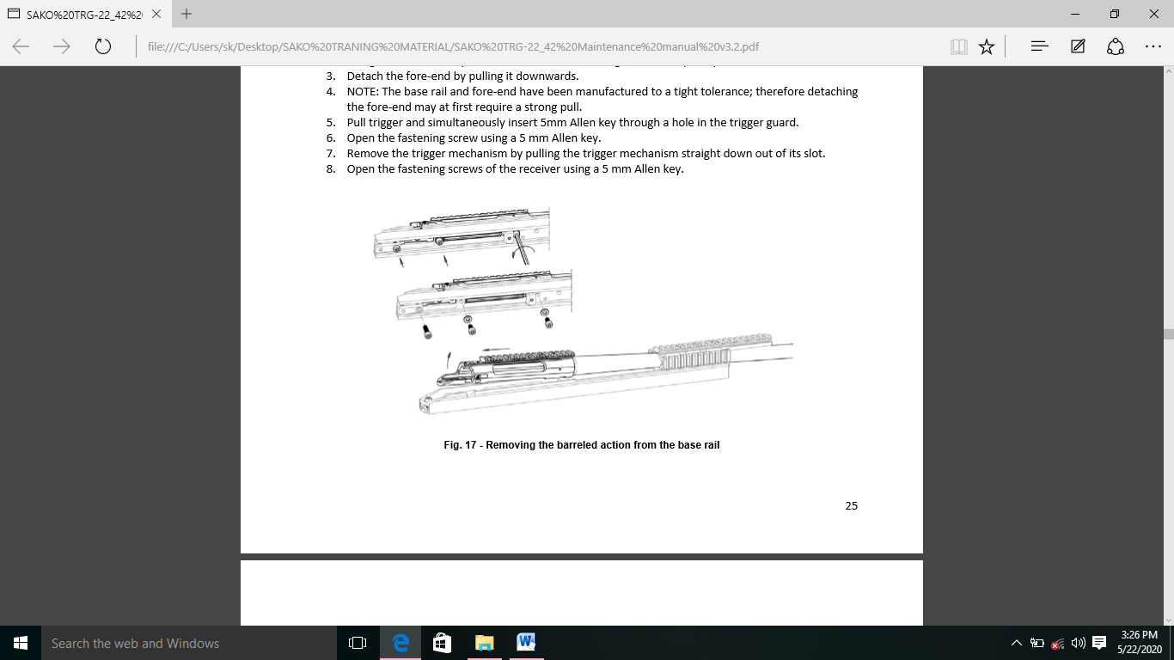(ag) 5mm allen key ka use karke receiver fastening screw ko kholen.

(ii) **Installing the Barreled Action to Base Rail**

(aa) Insure karein ki receiver or base rail ki bedding surface saf hai. yadi jaruri ho to receiver ki bottom surface par halka gun oil film laga sakte hai.

**Note: -** Receiver or base rail ki bedding ki surface per thick grease or bhot jyda oil hona hatiyar ke accuracy power ka nukshan ka karan baan sakta hai.

(ab) Ensure karein ki recoil lug base rail per betha hai or recoil lug ki height sahi hai.

(ac) Receiver ko base rail per install karke or fastening screw ko dhalka kash de taki receiver ko abhi bhi shift kiya ja sakta hai.

(ad) Rear stock ko base rail per install karein or top fastening screw ko kash de.

(ae) Trigger mechanism ki sahi jagah ka khayal rakte hua trigger mech ko uske slot me install karein.

(af) Recoil lug ke khilaf barreled action ko piche ki aur dhakale aur sath hi front fastening screw ko kash de.

(ag) Trigger mechanism khol de.

(ah) Bacha hua fastening screws ko tight karein.

(aj) Mechanism ki sahi posn ka dhayan rakte hua trigger mech ko uske slot me install karein.

(ak) Base rail per fore end install karein fastening piece ko base rail me align karne ke liya aap fastening screw ko dali gayi allen key ka upyog kar sakte hai.

(al) Fore-end fastening screws ko kase.

(am) Bolt or mag dalein or baki accesoseris ko ikatha karein.

(b) **Replacing the Fastening Screws.** Yadi fastening screw ke head per ya threading damage ho gaye hai unhe sahi roop se tight karna possible nahi hai to screw ko naye spare screw se badalna chahiye.

(c) **Bolt Repairs**

(i) **Bolt ko badalna**

(aa) Bolt ko ek spare Bolt ke sath badal dena chahiye agar locking ya cocking surface per kafi pitting ya flashes paya ja sakte hai. Bolt ke face per kafi rust lunge ke karan Bolt ko ek spare Bolt ke sath badal dena chahiye.

(ab) Jab head space ki problem ati hai to Bolt ka inspection kiya jana chahiye.

(ac) Defective Bolt ko spare Bolt ke sath replace kardena chahiye.

(ad) Jab Bolt ko badal diya jaye to head space ko hamesha GO/NO GO gauge ka istemal karke inspection kiya jana chahiye.

(ii) **Firing pin Assembly ko badalna.** Firing pin aur cocking peace ko parmenent ek sath fasten kiya jata hai. Yadi firng pin ki problem ati ha to puri firng pin assembly ko ek spare ke sath badalna hoga. Bolt ko assemble karne se pahle Firing pin ke felav ko check karna chahiye.

(iii) **Firing Pin ki Assembly ko badlane ka karan Example ke taur per yeh ho sakte hai**

(aa) Primer leakage ke karan Firing pin tut gayi ha ya kharab ho gayi hai.

(ab) Firing pin ka ki protrusion bhot chota hai 1.3mm se kam ya bahut adhik, 2.1mm se jyda.

(ac) Firing pin ya cocking peace ka joint dheela hogya ha to.

(ad) Cocking piece ka cocking notch ki surface ko cocking ramp ke khilaf seized kar liya gaya ha to.

(ae) Cocking shoulder ke sharp corner ko rounded kiya gya hai.

(iv) **Replacing the Firing Pin Spring.** Firing pin spring ko replaced kiya jana chahiye yadi yeh apni takat is haad tak kho gaya hai ki primmer ki reliable Firing ko banaya nahi rakha ja sakta hai. Firing pin spring ki free length 70 mm se jyda hona chiya.

(v) **Replacing the Bolt Shroud.** Bolt shroud ko spare ke sath replace karna chiya agar Bolt shroad se locking lug ko cease karne ke karan Bolt ko cock hard hogya ho.

(vi) **Replacing the Bolt Handle and Bolt Handle Knob**

(aa) Bolt handle knob ko friction dwara Bolt handle se fasten kiya gaya hai.

(ab) Relase karte samay 2mm Allen key ka upyog karein or locking scre ko tabtak kholen jabtak ki screw ka head knob ki surface ke saman na hojaye. knob ko ghuma kar tab tak nikale jab tak vo bahar na nikal jaye.

(ac) Reverse order me install karein. Bolt ke handle ko m6 screw or loctite 638 thread locking agent ka use karke Bolt se jora jata hai. Joint ko +150°C tak garam karke Bolt ke handle ko hatana sabse asan hai. Bolt handle ko assemble karte samay ek similar thread locking agent lagana chahiye.

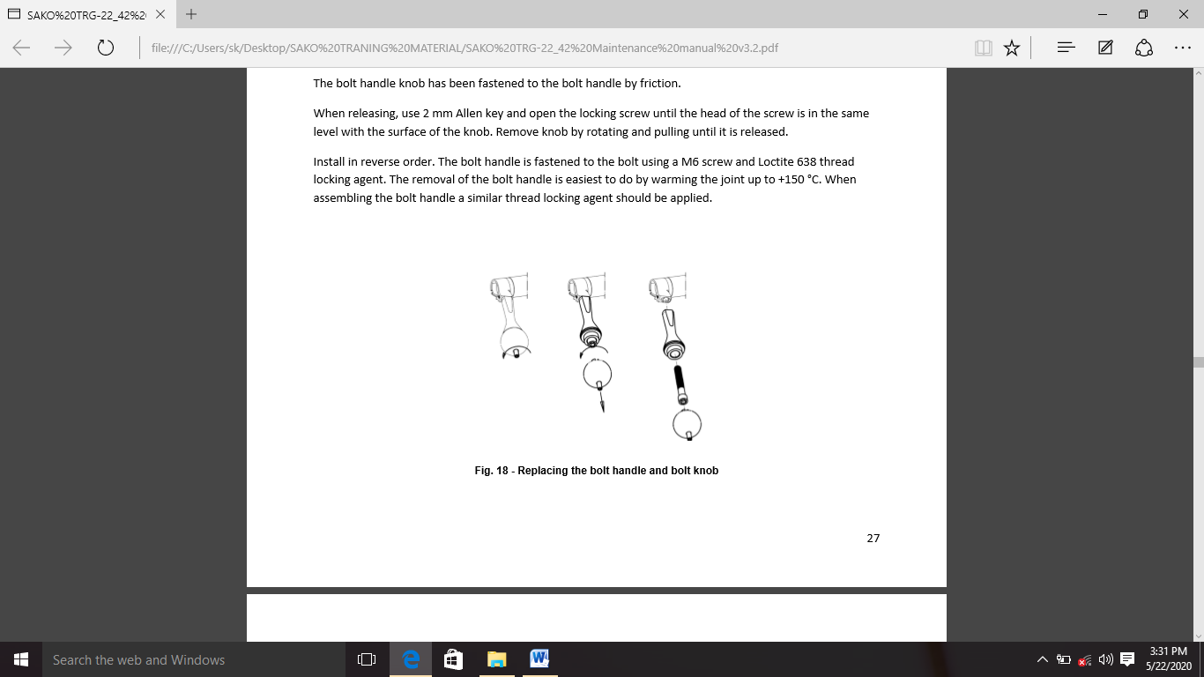

(d) **Extractor**

(i) **Extractor ko Badalna.** Extractor ko badly tabhi kiya jana chahiye jab veh tut gaya ho anya sabhi kharabi ko Bolt head per stith extractor bore or extractor spring ki safai karke or jab awashyak ho, extractor spring ko spare se badal kar haal kiya jata hai. Extractor spring ke bore ko saf karte samay aap 2.5mm bit ka use kar sakte hai. Jise haat se ghumaya jata hai.

(ii) **Replacing the Extractor Spring. E**xtractor spring ko spare ke sath badla jana chahiye agar extraction ki samasya ka samna karna paad raha ha or extractor spring ko defected paya gaya ho extractor spring ki free length 10 mm honi chahiye.

(iii) **Extractor ko kholna aur Jodna**

(aa) Extractor ko extractor or extractor plunger ke bich ek narrow blade screw driver daal kar or screw driver ke sath extractor ke biche head ko utha kar nikala jata hai.

(ab) Dhayan se dekhe ki extractor plunger or extractor spring gir kar kho na jaye.

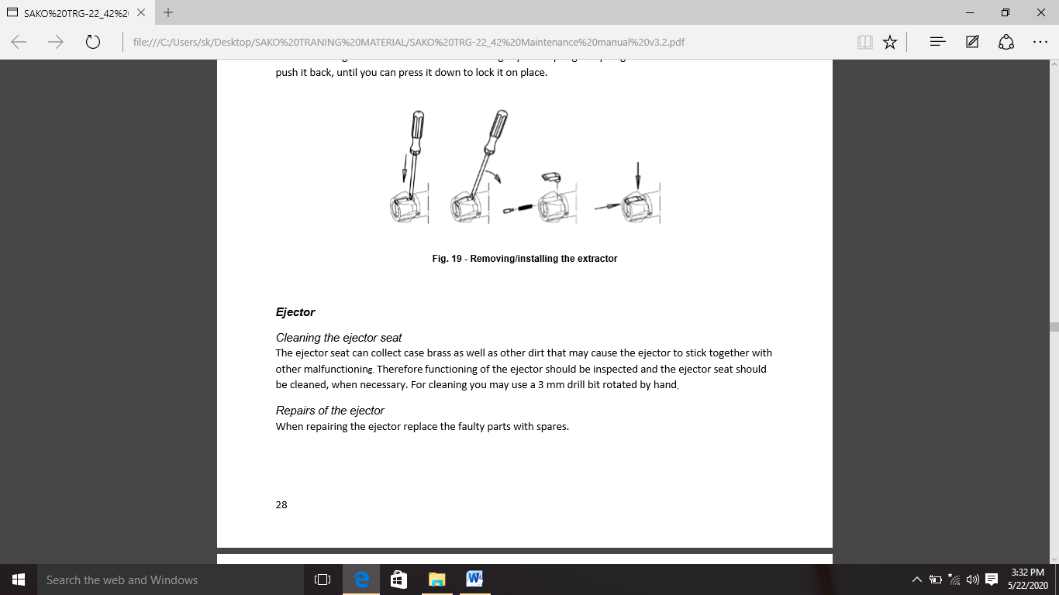(ac) Extractor insert karte samay pahle halke oil se lagi hui spring or plunger ko dalein. Extractor dalein or ise tabtak piche push karein jab tak aap ise posn per lock karne ke liye neeche daba sakte hai.

(e) **Ejector**

(i) **Cleaning the Ejector Seat.** Ejector seat ke brass or dusre dirt ko remove kar sakta hai jo ejector ko anya kharabi ke sath chipak sakti ha isliya ejector ki karya pranali ka niriksahan kiya jana chahiye aur awasyakta padne per ejector seat ko saf kiya jana chahiye safai ke liye aap hath se ghumaye gaye 3 mmmki drill bit ka upyog kar sakte hain.

(ii) **Repairs of the Ejector. Ejector ki maramat karte amay kharab purjon ko purjon se baadal dein.**

(iii) **Replacing of the Ejector Spring.** Ejector jo apni takat kho chuka hai use ek atirikit ke sath badal dena chahiye halanki ejection samasyon ka sabse aam karan ejector seat mein bhari kanon ke karan chipkna hai. Ejector spriing ki relenght 13m honi chahiye.

(iv) **Ejector ko Kholna aur Jodna**

(aa) Ejector ko hatane ke liye 2.5mm spring pin ko tap kareinin.

(ab) Drift pin ko sabadhani se bahar nikalein. Taki ejector spring ke sath sath milkar Bolt face se bahar na niklein.

(ac) Sabdhan rahein ki ejector or ejector gira or kho na jaye.

(ad) Ejector ko assemble karte samay is edrift pin ke sath sahi sthiti mein nirdeshit kareinin. Jab ejector betha ho Bolt ke viprit disha se spring pin mein tap kareinin. Ejector ko assemble karte samay hmesha ek naye spring ka upyog kareinin.

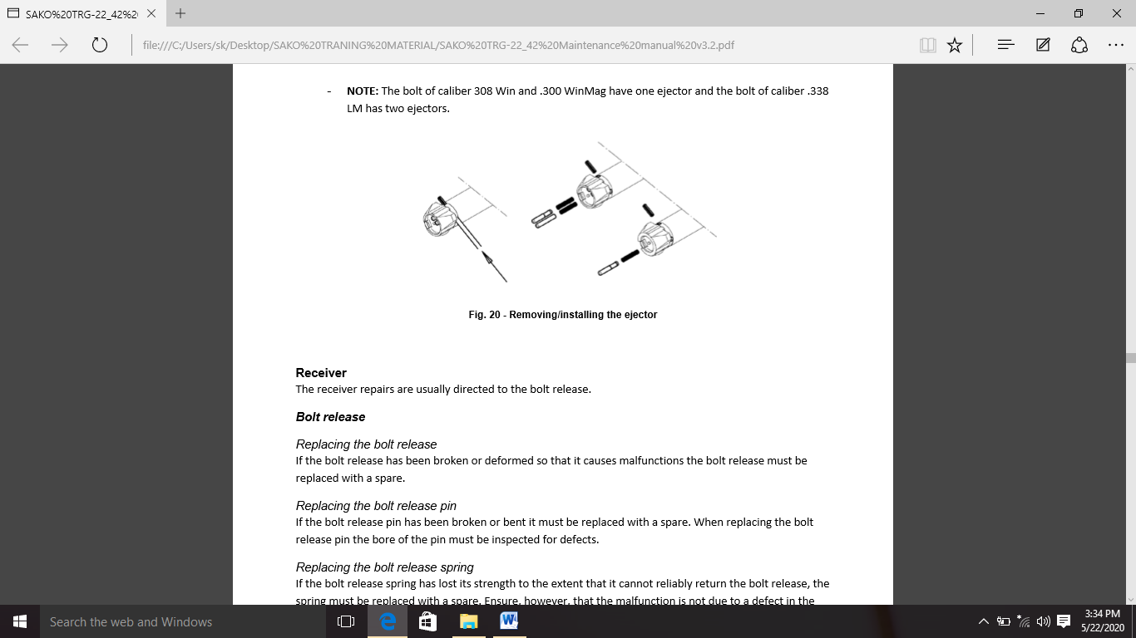**Note: -** Callibre .308 bin or .300 win mag ke Bolt mein ek ejector hota hai or callibre .338 LM ke Bolt mein 2 ejector hote hai.

(f) **Receiver.** Receiever ki maint aamtaur par Bolt releaseke liye nirdeshit ki jati hai.

(i) **Bolt Release.** Bolt release ko badalna yadi Bolt release ko tod diya hai. Ya vikrit kar diya hai. Taki yeh kharab ho jaye to Bolt release ko ek atirikit ke sath badal diya jana chahiye.

(ii) **Replacing the Bolt Release Pin.** Yadi Bolt release pin toot gaya hai ya mudha hua hai to ise ek spair ke sath badal diya jana chahiye. Bolt release pin ko badalte samay pin ke bore ka fault ke nirikshan kiya jana chahiye.

(iii) **Replacing the Bolt Release Spring.** Bolt release spring ne apni takat is had tak kho di hai ki yeh Bolt release ko vishwashniye roop se wapis nahi kar sakta to spring ko spair ke sath badal dena chahiye. Halanki yahin kareinin ki khrabi Bolt release ya uske pin mein khrabhi ke karan nahi hai. Bolt release spring ki free length 8.5mm honi chahiye.

(iv) **Bolt Release ko Kholna aur Jodna**

(aa) Base rail se barreled action ko alag karein.

(ab) 2.5mm flat screw driver ka upyog kakre Bolt release pin ko lag karein.

(ac) Aap ek flat screw driver lekar or iske sath reiver ke khilaf Bolt release ko daba kar pin ko asani se nikal sakte hai.

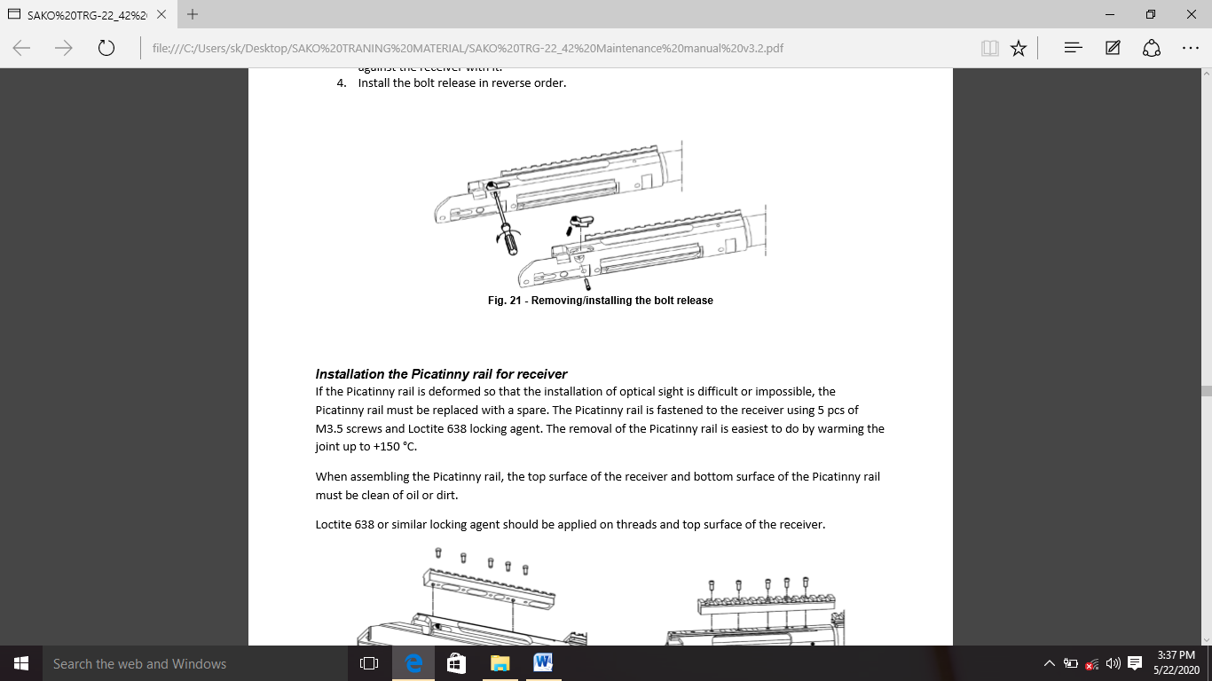(ad) Bolt release ko reverse order me stapit karein.

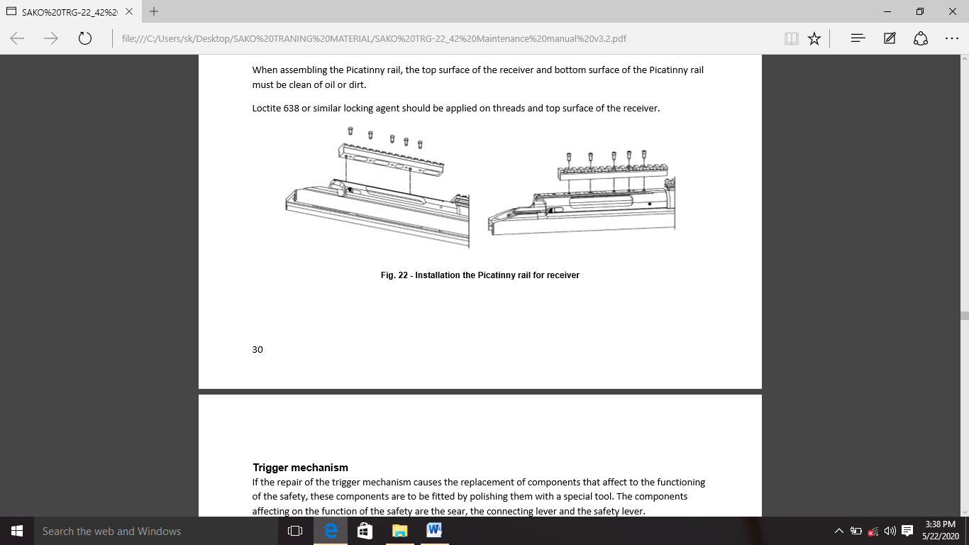(g) **Picatinny Rail ko Receiver se Jodna.** Yadi picatinny rail deformed ha taki optical sight ki stapna muskily a asambhav ho to picatinny rail ko ek spare ke sath badlna chahiye. Picatinny rail ko M3.5 scew 5 piece or lock tight 638 locking ka upyog karke receiver se jora jata hai. Joint ko +150 c tak garam karke picatinney rail ko hatna sabse asan hai. Picatinny rail ko assamble karte samay receiver ke top surface or picatinny rail ki bottom surface oil ya dust se saf honi chahiye lock tight 638 ya isi tarah ke locking agent ko thread or receiver ki top surface per lagaya jana chahiye.

(h) **Trigger Mechanism**

(i) Yadi trigger mech ki repair suraksha ke kaam kaaj ko prabhavit karne wale components ke replacement ka karan banti hai to components ko ek spare parts ke sath polish kakre fit karna chahiye. Safety function ko prabhavit karne wale componets sear, connecting lever or Safety lever hai.

(ii) Anya trigger mechanism components ki Safety function per prabhav nahi dalte hai. Isi liya samanaya roop se karya ko mante hua replace kiya ja sakta hai or repair samapt hone ke baad trigger mech ke adjustment ka puri tarah inspection kikya jata hai.

(iii) Trigger mech ki koi bhi repair karne ke liye sandharb ke roop me attached drawing ka palan karein.

(j) **Safety Lever ko Badalna aur Fit Karna**

(i) Safety lever ko hmesha ek nischit trigger mech me sanchalit karne ke liye individualy roop se fit kiya jata hai. Safety lever ki clutch surface ko polish karke fitting ki jati hai taki Safety ko vishvashniye roop se on kiya ja sake, yadi Safety ko on kiya gaya ha to trigger first pull ke baad nahi chalta ha.

(ii) Yadi trigger pahle kichne ke baad chalta hai jab ek uchit force ke sath squeez kiya jata hai or Safety on ho jati hai to Safety lever ko ek spare ke sath badal diya jana chahiye. Is special trigger mech me kaam karne ke liye spare ko fit kiya jana chahiye jab Safety operation ka testing kiya jata ha to extra force ka upyog trigger mech ke nuskshan ke jokhim ke karan varijit hota hai jo iske karye ko unvishvasniye bana sakta hai.

(iii) Safety lever ko detach karne se pahle Safety spring ke support per groves se spring ke samne wale hisse ko utha kar Safety lever spring hata de jab Safety trigger frame se bahar ajayegi tab ek pryapt punch ka use karke ek sath praypt punch ka use karke Safety ko neeche push kakre or Safety ko alag kar diya jata hai. Punch ki halki tapping se Safety ke shaft per push ko majbur kiya ja sakta hai. Sear ko neeche rakhne se uska spring bore or saft ke bich me nahi girega. Safety lever ko fit karte samaya ap pahle sear spring ke bina Safety function ka parikshan kar sakte hai.

(iv) Safety fit karte samay sear spring ko uske sthan per push karna shuru karein or safet shaft ko relative opening per push tabtak jari rakhe jabtak ki shaft ka sira sear spring se na takra jaye. Ek narrow 2.5 mm bracket me blade screw driver le jiske sath aap Safety shaft ko ek sath daba kar sear spring ko compress karte hai jabtak ki ye screw driver se takra na jaye screw driver ko utare Safety shaft ko uske sthan par push karein. Ant me upyukt pliers ka istemal karke Safety lever spring install karein.

(k) **Replacing the Sear**

(i) Agar sear tut gaya hai ya cocking surface damage ya broken ho gayi hai to use spare ke sath replace karein. Sear ke fault se rif ki accurate triggering ya unreliable cocking ho sakti hai. sear ke replacement se Safety functioning me change asakta hai. Yaha tak ki safet ke replacement ki aur bhi lejaskta hai isi liye ye salah di jati hai ki repair ki karwai kisi yogya person dwara ki jaye uske pass Safety componets ko fit karne ke liye jaruri special tool ka hona awasyak ha.

(ii) Pichle chapter me btaye anusar pahle Safety lever ko hatane ke liye Safety lever ko alag karein 2.5 mm punch ka use karke iske pin ko tap karke sear ko aalag kiya jata hai.

**Note: -** Iski transverse movement ko speed ko rokne ke liye pin ko secure kiya gaya hai. Instalation ke baad pin ko jaise tha vasa hi secure karna chahiye.

(iii) Safety function ko verify karke sear ki installation ko antim roop de ayadi jaruri ho to Safety ke vishvasniye function ko sunischit karne ke liye Safety ke anya componets ke sath fit karein. Piche chapter me charcha kiye gaye niyamo ka palan karte hua Safety ko sapre se badlna jaruri ho sakta hai connecting lever ko badalna yadi ya toot gaya hai ya iski cocking surface damage ya kharab ho gayi hai sear ke fault rif ke achuk triggering ya unreliable cocking ka karan baan sakte hai. Connecting lever ko badalne ke liye Safety function ka connecting lever se badalne se Safety ke function me badlav asakta hai. Yaha tak ki Safety functioning me badlav asakta hai. Yaha tak ki Safety ko replace karne ki nobat bhi asakti hai. Isi liye ye salah di jati hai ki repair ki karwai ek qualified person dwara ki jaye. Jiske pas Safety function ko fit karne ke liye jaruri special tools available ho.

(l) **Removing the Connecting Lever**

(i) Connecting lever ko hatane se pahle trigger guard ko 2.5 mm punch ke use karke do sabse piche wale pin ko hata kar alag kiya jana chahiye pin ko lag karne ka baad trigger guard or iske washer ke sath fastening screw ko alag kiya jata hai.

(ii) Pichle chapter me described Safety lever ko trigger pe adjustment screw or uske screw ke sath alag karein Safety lever or pin ko ab hataya ja sakta hai.

(iii) Trigger pin ko 2 mm punch ka use karke tap out karein or trigger assembly ko hata de

NOTE: Iski shifting ko rokne ke liye pin ko secure kiya gaya hai.

(iv) Connecting lever ko ab 2mm punch ka use karke connecting lever ko hata kara lag kiya ja sakta hai.

**Note: -** Pin ko hilne se rokne ke liya secure kiya gaya hai.

(m) **Connecting Lever ko Jodna.** Connecting rod ko install ke baad iski shifting ko rokne ke liye iski pivot ko secure kiyajana chahiye.

(i) Trigger attaching karne se pahle 1.5 mm allen key ka use karke pahle pull adjust screw hata dene chahiye. Trigger front surface per slot me pahle pull spring ka pata lagana chahiye.

**Note: -** First pull spring ki tulna me pahla pull spring bahut kamjor hai. Trigger ke assamble hone ke baad pin ko uski shifting se bachane ke liye secure kiya jana chahiye.

(ii) 2.5 mm allen key ka use karke adjustment screw ke sath trigger weight spring install karein or 1.5mm allen key ka pahla pull adjustment screw yadi jaruri ho to adjustment screw ko milled thread locking agent lock type 222 ya saman ke sath secure karein.

(iii) Safety functions ke jaanch karein yadi jaruri ho to Safety mech ke spare component ke sath karya karne ke liye Safety pradan karein yadi jaruri ho to Safety ko ek spare ka sath badlen. Verification karne ke baad Safety lever or Safety pin install karein taki iska slot point piche ki aur ho.

(iv) Pichle chapter me btaye anusar Safety lever ko fasten karein.

(v) Aant me trigger mech fasten screw ko uske washer or trigger guard ke sath do groves pin ka upyog karke ikatha karein.

(n) **Replacing the Remaining Trigger Mech Components.** Trigger mech sehisso ko badalne se Safety ke function per koi prabhav nahi padta halanki trigger mech ke adjustment ko savdhani se verify kiya jana chahiye yadi trigger componets me se kisi ko badal diya gaya ho pichle pergraph me trigger mech component ko alag karne or install karne par charcha ki gayi hai.

(o) **Stock Repairs**

(i) **Fore-End.** Ek damaged fore-end ko pichle section me described ke roop me replace kiya gya hai.” base rail se barrel tak ki karwai ko hatana ya install karna”.

(ii) **Bottom Rail.** Ek bottom rail ko tab badla ja sakta jab 4 screw ko lips head screw driver se hata diya gaya ho aur spare ko ushi screw ko tighten kiya gaya ho. Sabhi damaged screw ko ek hi samay me badla jana chahiye. rail ko fastening karte samay is baat ka dhayan rakhna chahiye ki screw is tarah se rakha jaye ki sling swivel stud freely rail ke sath move kr sake.

(iii) **Fore-end Fastening Pieces.** Ek damaged fore end ko badlne ke liye fore end ko alag kiya jana chahiye. Respective fastening screw ko puri tarah se khol kar fastening piece ko hata diya jata hai. fastening piece ko jodte samay dhayan de ki iske bevel ko mag ke bagal me fateing piece ke exception ke sath aghe ya piche rakha ja sakta hai veh fasting piece ek mag guide ke roop me kaam karta hai or bevel wale hisse ko piche ki aur rakha jana chahiye.

(iv) **FixedStock.** Nischit stock mold foamed polyurethane se bana hota hai. Fixed stock ki repair nahi ki jaskti hai or damage fore end aur/ ya fixed stock ke sath damaged fasting scew rail or swivel stud ko purjo me badla jana chahiye.

(v) **Replacement of the Fixed Stock.** Fixed stock ko niyam anusar badla ja sakta hai :-

(aa) lagbhag ek mod per 5 allen key ka upyog karke upper or bottom fastening screw kholen.

(ab) Rear stock ko piche ki aur kich kar alag karein.

(ac) Rear stock ko install karne ke baad fastening screw ko dhayan se tight karein.

(ad) Yadi aap rear stock ko badalte hai to aap ko recoil pad , cheek peace or sling ko naye fixed stock me fastening ke liye jaruri components ko assemble karna hoga.

(p) **Cheek Piece.** Cheek piece ko badlane ke liye 5mm allen key ka use karke fastening screw ko lagbhag 4 mode se dheela karna shuru karein. Jabtak ki aap cheek piece ko iske fasting nut aur rear stock se optional spacer ke sath slide nahi kar sakte ek naye cheek piece ko jodne ke liye pahle fastening screw ko rail per rakhe. Screw ko fastening screw ka use karke optional spacer ke saath cheek piece ko tight karein. Fastening screw ko tight karein.

(i) **Cheek Piece Rail**

(aa) Phillips-head screw driver ka use karke screw kholen.

(ab) Spare rail ko usi screw se tight karein

**Note**: - Yadi screw damage hai to unhe dbadal dena chahiye.

(ac) Rail ko install karte samay is baat ka dhayan rakha jana chahiye ki screw ko is tarah se rakha jaye ki cheek piece ko tight karne wale nut ko rail ke sath freely replace kiya jasake.

(ii) **Recoil Pad**

(aa) Recoil pad assambly ko ek spare part ke saath badalane ke liye, 5 mm allen key ka upayog karke, recoil pad ke center mein sthit screw ke sath attach karien, jab tak ki recoil pad assambly ko hataya nahi ja sakta.

(ab) Recoil pad mein ek o-ring hai, jo jude huye screw ko bat plet mein girne se rokta hai. recoil pad base ka juda screw rail par rehta hai.

(ac) Recoil pad assembly ko badalane ya spair ki quantity ko bdlane ke lie, 4 mm allen key ka upayog karake recoil pad ke screw ko kholakar recoil pad ko alag karein.

(ad) Recoil pad ko jodne ke liye aap middle screw aur uske washer aur o ring ko recoil pad base se jod kar shuroo kar sakate hain taaki antim roop se jodne ke dauraan ve pakad mein aa saken.

(ae) TRG -42 snaipar Rifle ke opareting manual mein spair ki sankhya ke sambandh mein allen screw ki lambai ke baare mein jo kaha gaya hai, use dhayan mein rakhate hue attach screw aur sambandhit nut ka upayog karake rikoil paid ko ikattha kiya jaata hai.

(ef) Allen screw ka upayog karake recoil pad assambly ko rear stock mein bandha jaata hai.

(iii) **Recoil Pad Rail.** Damage recoil pad rail ko bdlane ke liye pehle butt plate assambly ko alag karein.

(aa) Philips-hed ko screwdriver ka upayog karake screw kholenn.

(ab) Ishe shikanje ke saath spair rail ko jakaden

**Note**:- Yadi screw kharab ho gye hain to unko badal diya jana chaahie

(ac) Attach screw (jude) screw alag-alag lambai ke hote hain, sbase uper ka screw sbase lamba hota hai. Rail ko sthapit krate samay is baat ka dhayan rakha jana chaahie ki screw is tarah se lagaye gye hain ki butt plate jude nut ko rail ke saath freely roop se badli kiya ja sake.

(p) **Folding Stock.** Folding stok steel, aluminum aur poleyurethen se bana hai. Folding stock ke damage hisse ko hatta kar aur ek neye hisse ke saath bdalkar thik kiya ja sakta hai.

(i) **Pistal grip se rear stock body ko hatana**

(aa) 4 mm allen key ka upayog karake pistal pakad ko hata den

(ab) 2mm drift pin ki madad se securing pin ko bhar nikalien

(ac) Hinj pin ko htane ke liye locking catch aur fold stock ko dabakar folding stock kholenin

(ad) Hing pinon ko daba kar bahar nikalien

(ae) Uper hinj/loking device ko htana

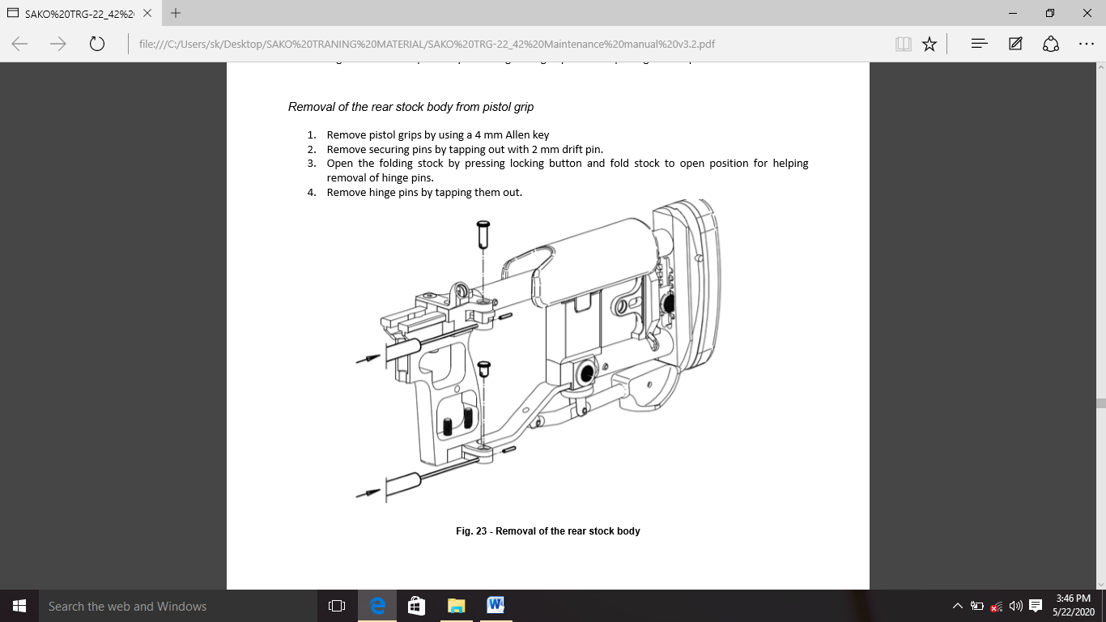

(ii) **Removal Upper Hinge/Locking Device**

(aa) 4 mm allen key ka upayog karake pistal grip ko hata deyien.

(ab) 3 mm allen key ka upayog karke upper ke do screw ko nikale.

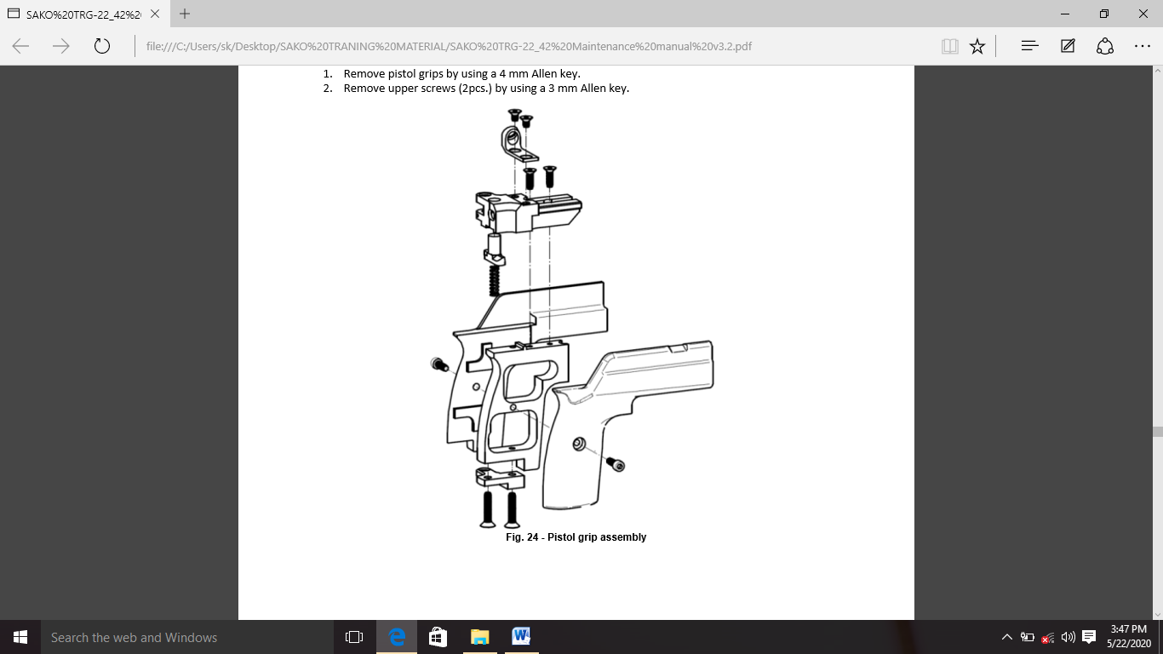

(

(iii) **Removal of Lower Hinge.**

(aa) Remove rear support hinge pin by using 3mm punch.

(ab) Remove lower hinge by using a 4mm Allen key.

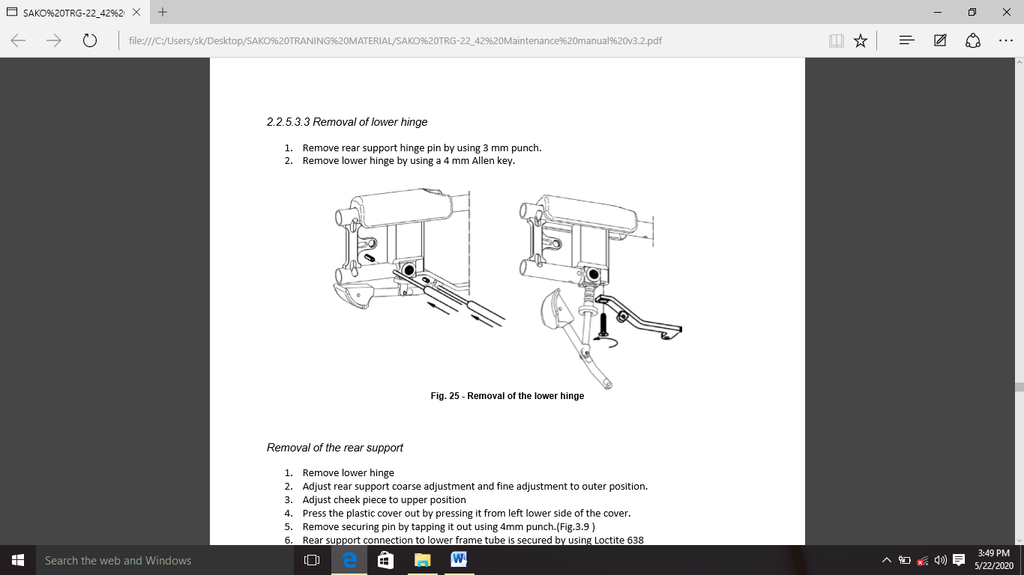

(iv) **Removal of the Rear Support.**

(aa) Remove lower hinge

(ab) Adjust rear support coarse adjustment and fine adjustment to outer position.

(ac) Adjust cheek piece to upper position

(ad) Press the plastic cover out by pressing it from left lower side of the cover.

(ae) Remove securing pin by tapping it out using 4mm punch.

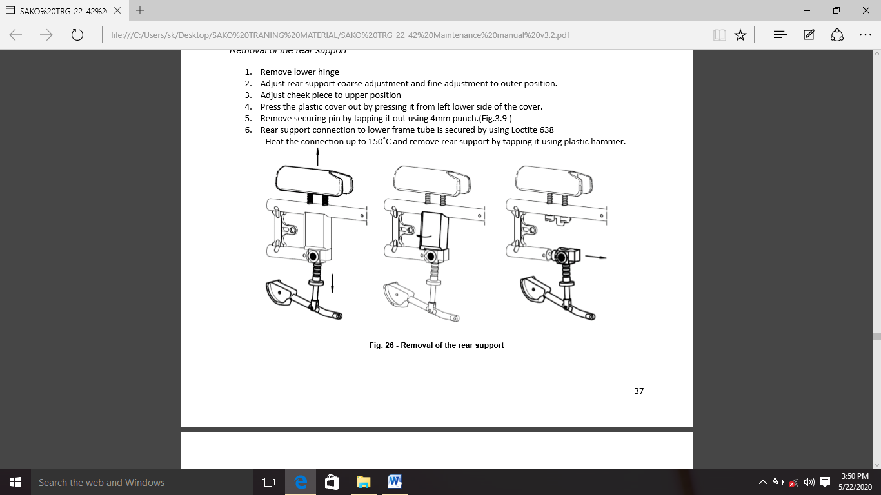(af) Rear support connection to lower frame tube is secured by using Loctite 638 - Heat the connection up to 150˚C and remove rear support by tapping it using plastic hammer.

(v) **Removal of Cheek Piece**

(aa) Remove lower hinge and plastic

(ab) Remove c-clips.

(ac) Keep cheek piece locking catch pressed and slide cheek piece out.

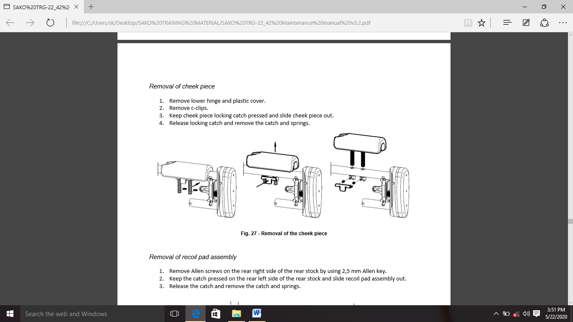(ad) Release locking catch and remove the catch and springs.

(vi) **Removal of Recoil Pad Assembly**

(aa) 2.5 mm allen key ki madad se pichle aur dihene

wale allen screws ko kholne

(ab) catch ko peeche ke stock ke peechhe baeen aur dabakar rakhen aur recoil pad assembly ko slid karein.

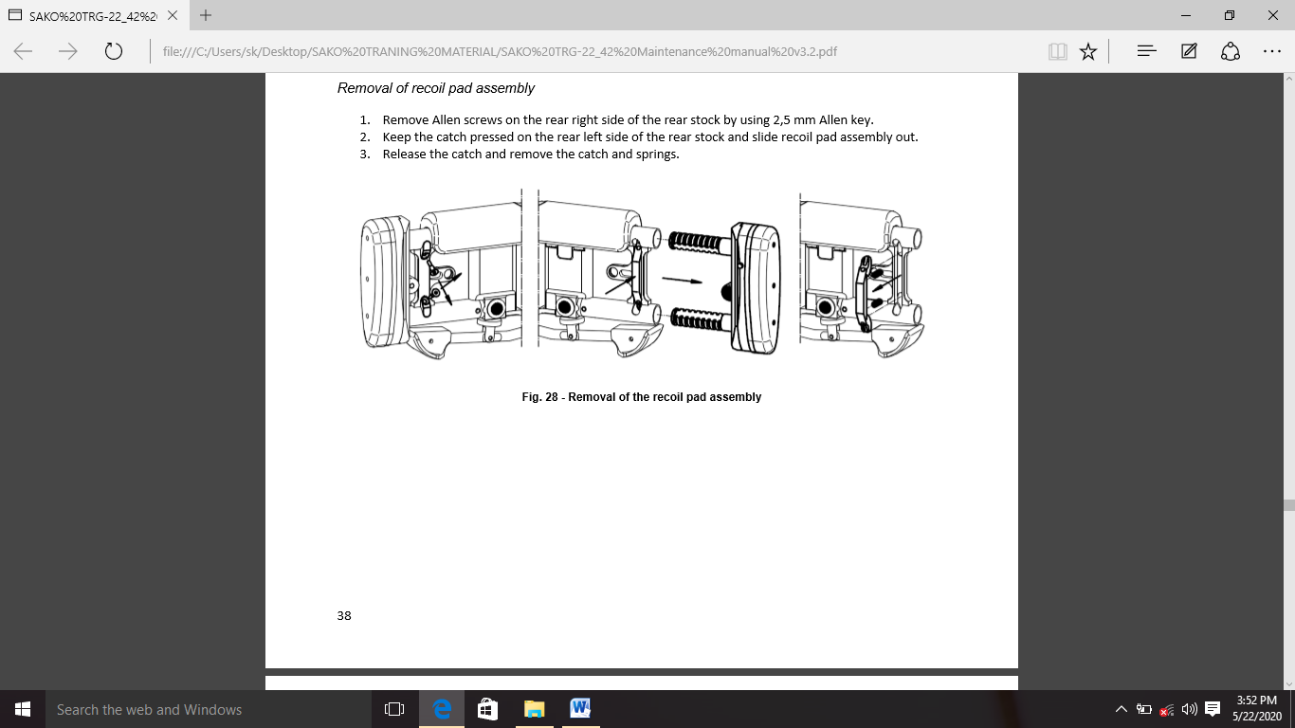(ac) Catch ko shodh den aur catch aur springs ko hata den.

(q) **Base Rail**

(i) Base rail ko alag karane ke liye pehle fore end, peeche ke stock aur pichhale bhago mein batae gaye barreled action ko hata den. assembly ko oposite sequence mein kiya jaata hai.

(ii) Yadi base rail damage ho gaya hai to ushe ek atirikt se badala jana chaheye. damaged base rail se aage ke upayog ke liye bina damage recoil lug, side reinforcement plate, stock adapter aur magazine ke front guide ko hata diya jana chaheye, jaisa ki iss paragraph mein baad mein kiya gaya hai.

(iii) Base rail ko assemble sambandit guidence is parkar kiye jayege .Rifle ke final assembly se pehle magzine front guid ko lagana na bhulen. halan ki iska combination trigger mechanism ke assembly ke sath milakar kiya jaata hai. magazine front guide ka level piche ke aur hona chaheye.

(r) **MMRS Rail.** MMRS rail ki base rail ko screws and alignment pins ki shayeta se tight kiya hua hota hai

(i)  **Kharab MMRS Rail ko Badli Karne ka Tariqa**

(aa) 2.5 mm allen ka upyog kakre 8 pc fastening screw ko nikale or 2.5 mm drift pin ka upyog karein or 4 pc alignment pin ko hata de.

(ab) Spare MMRS rail ko base rail per install karein or fastening scrfew ko lose karein.

(ac) MMRS rail ko abhi bhi moce kar sakte hai. Loctite 638 thread locking agent ka istemal karke.

(ad) Alignment pin ko install akre

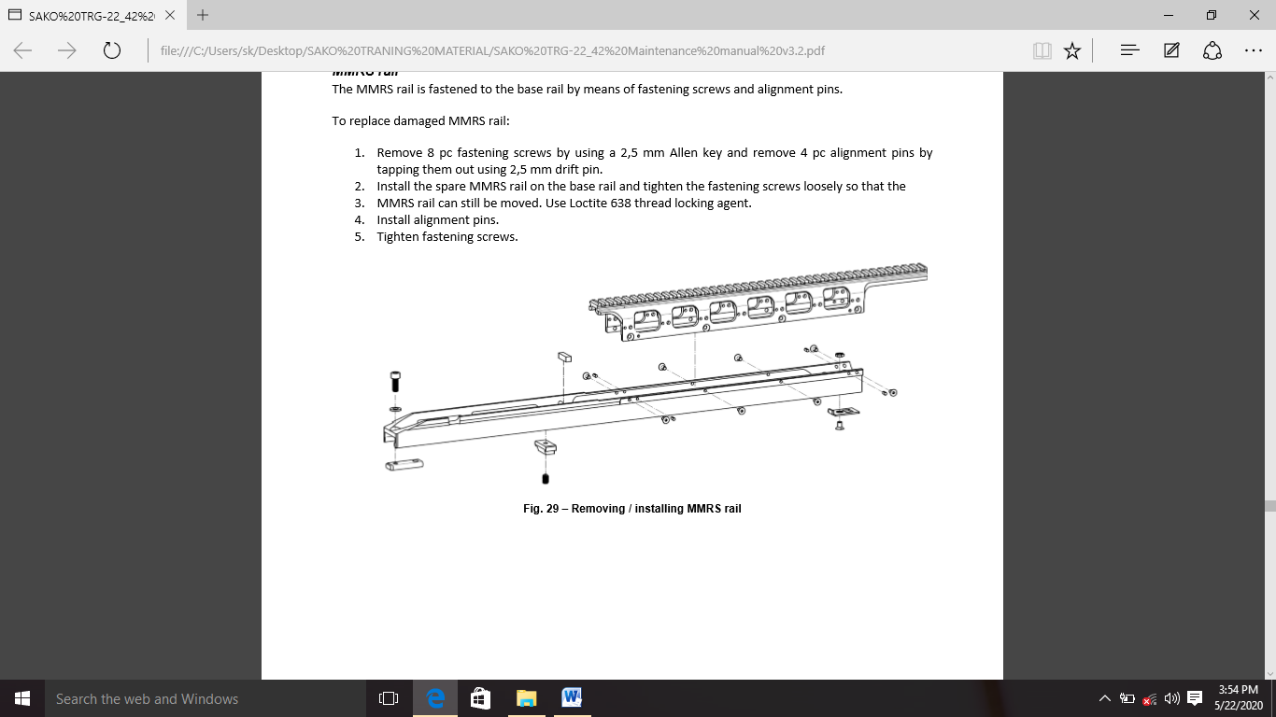(ae) Fastening screws ko tight karein.

(s) **ITRS Rail.** ITRS rail ko 3 screw or nut dwara base rail ko joda jata hai.

(i) **Replace Damaged ITRS Rail**

(aa) 3 fastening screws and nuts ko remove karein.

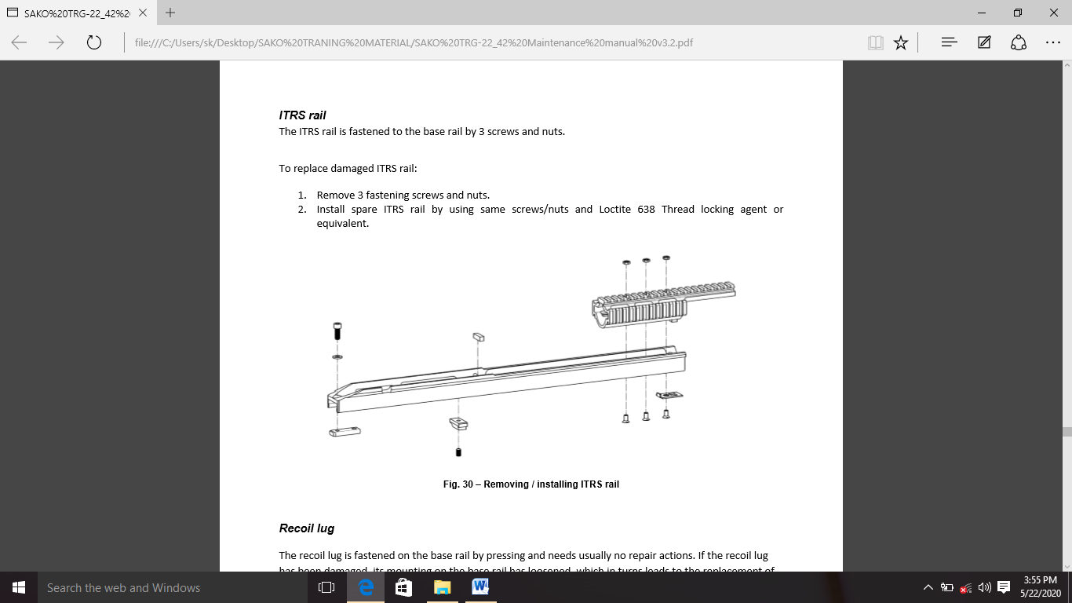(ab) Spare ITRS rail ko install karein or Loctite 638 Thread ka locking agent or equivalent ka istemal karein.

(t) **Recoil Lug.** Recoil lug ko dabakar base rail par bandha jata hai aur aam taur par kisi repair ki jarurat nahi hoti hai.yadi recoil lug kharab ho gya hai to base rail par iske mounting dheele ho gaye hain jis ki badle mein badii rail ko badalne ki jarurat hoti hai.yadi jaruri ho to base rail ke botto/base per ched ya surak ke madyam se ise tapping karke 5mm punch ka upayog karke base rail se recoil lug ko alag kiya jata hai.recoil lug ko ek copper ki plate ya isse tarah ki naram dhatu ka upyog karke lug aur hathode ke beech base rail ke groves main tapping karke wapas ikatha kiya jata hai. recoil lug base rail ke top se jyadatar 3 mm tak badh sakta hai. recoil leg ke kisi bhi unnecessary detaching se bachna chahiye.

(u) **Reinforcement Plate.** Yadi reinforcement plate kharab ho gayi hai to ise pichle paragraph main diye procedure ke anusar atirikt ke saath badal diya jana chahiye. dhayan den ki kholne ke liye kewal front fastening screw jaruri hai. yadi screw aur nut kharab hai to unhen spare se badal diya jana chahiye. Bipod ke positive latching ko verify kiya jana chahiye. Jab bipod ko base rail per lock kiya jata hai to bipod latch aur reinforcement plate ke beech ek chota sa antar dikhai dena chahiye

(v) **Rear Stock Fastening Piece.** Stock fastening piece vastav mein base rail per fasten nahin karte hai. lekin yeh Rifle ki assembly ko asan banane ke liye aam-taur per peeche ke fastening screw aur washer ke saath base rail per chhod diya jaata hai rear stock fastening piece stapit karte samay dhayan dein ki bina thread ki hole ka reccess neeche ki or hona chahiye taaki receiver ke sabse peechhe ke fastening screw ko receiver ko uske bore me kafi dor tak pahunchaya ja sake.

(w) **Adjusting the Magazine Front Guide.** Mag front guide yeh ensure karne ke liye hai ki mag, mag mein apni sahi position tak achhi tarah se pahunche aur iss tarah attach karne mein madad karein. Mag front guide ko base rail ke longitudinal groovs ke racess mein fasten kiya jata hai aur allen head set screw ke sath secure kiya jata hai.

(i) mag front guide ko hatane ke liye 3mm key ka istmeal karke, set screw ko lagbhag ek baar mode jiske baad app mag front guide ko base rail ke samne se slide karke laga sakte hai.

(ii) jab mag front guide install karte samay is baat ka dhayn rakhe ki bevel wala side mag box ke piche ki aur ho.

(iii) magazine front guide ko adjust karne ke liye trigger mech ko install karne or iske opening me ek mag dalne se shuru karein.

(iv) set screw ko dheela karein mag front guide ko mag ke khilaf mag ko push karein or screw ko tight karein, kai mag ke sath re-install ki karwai karein or ishe ke anusar adjustment ko dono aur verify karein.

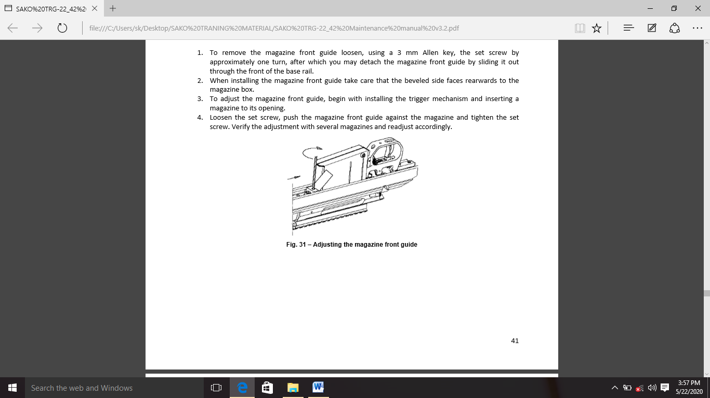

(x) **Bipod.** bipod adjustment or latching me kharibi ki samsya ko haal karne ka sabse fast or most effective tarika hai, bipod ko ek assembly ke sath replace karein.

(i) **Replacing the Bipod Latch. Damaged bipod latch** ko badlane ke liye, latch pivot ko bahar puch karne ke liye 2.5mm drift pin ka use karein. Iski shifting ko rokne ke liye pivot ko dono aur se secure kiya jata hai. pivot ko hatane ka baad latch or iske spring ko hataya ja sakta hai. latch ko assemble karne ke liye, spring ke top head ko latch me dalna ha or screw driver ya saman ka use karke spring ke bottom head ko support per slot me Guide ke roop me, seat ke opposite direction se dala gaya driftr pin ka use karke pivot ko apne seat me tap kiya jata hai. shifting ko rokne ke liye seat ke kinaro par det ke sath dono heads per pivot ko secure kiya jana chahiye.

(ii) **Repairing the Bipod Leg(s). agar leg damage** ho jata hai to ise spare ke sath badalne ki advice di jati hai.

(aa) Damage leg ko disassemble karne ke liye aapko leg assembly ke bottom part me located rivet ko hata dena chahiye. Rivet ke base ko ek suitable press me dalein aur leg bipod ko rivet se tab tak tap karein jabtak vah dhila na ho jaye. jab latch ko ek sath baar baar dabaya jata hai to leg ko ab pipe se bahar nahi nikala ja sakta hai.

(ab) yadi leg bend hua ha to ishe pipe se niakalna muskil ho sakta hai.

(ac) leg ke alag hone ke baad latch or letch spring ko pipe se hataya ja sakta hai. damaged bipod part ko sambhandit spares ke sath badal kar reverse order me assemble ki jati hai.

(ad) yadi leg pipe ko badalne ha to iske fasten pin ko badla jana chahiye bipod leg ko jorte samay rivet ko bhi naye se badle.

(y) **Muzzle Brake.** Muzzle break ki repair karein, yadi damage ho or jaruri hone per muzzle break ki safai or screw ke replacement karein.

(i) **Removing the Muzzle Brake.** muzzle brake ko iske fastening screw ko lagbhag ek 1 turn se losse karke or mujzzle break ko counter clockwise ghumakar hata diya jata hai taki yeh loose na hojaye.

(ii) **Installing the Muzzle Brake.**  Muzzle break ko haat se clockwise ghuma kar install kiya jata hai jabtak ki muzzle break khulne se sahi disha me point na karein. Muzzle break ke thread ke counter sink barrel ke cylinder wale hisse par extend karna chahiye akhir me fastening screw ko tight hona chahiye. yadi rif me recoil ke neeche side me jump karne ki tendency ho to iski bharpai muzzle break ke opening ko jump ki direction me point karke ki jati hai.

(z) **Replacing the Barrel**

(i) Barrel ko badlte samay base rail se receiver ko unistall karein or agar Bolt stock muzzle break or sights iketha ho.

(ii) Barrel ko hatane ke liye, isse bareel wise bandhe or receiver wrinch ke sath receiver counter clock wise ghumaye, jab tak ki receiver barrel se alag na hojaye.

(iii) Molybdenum grease ke sath barrel ke tread ko lubricate karein or barrel ko barrel vise se tighten karein. (behtar friction paidda karne or opcharik surface ko nukshan se bachane ke liye barrel or barrel vise ke bich normal copy paper ka istemal kiya ja sakta hai)

(iv) Receiver ko barrel thread per dalein or ise haat se ghuma kar tabtak tight karein jabtak receiver band na hojaye.

(v) No go gauze ko chamber me dakhil karein or verify karein fir moderate force ka use karke Bolt stop ho jata hai.

(vi) receiver wrinch ke sath receiver ko clockwise me thoda thoda karke tabtak ghumaye jab tak ki Bolt ko chamber me dalein gaye gauze ke sath moderate force laga kar close nahi kiya ja sakta. Tightening torque 80mm se adhik nahi hona chahiye.

(vii) Ensure karein ki chamber me go gauge dalne per Bolt ko moderate force laga kar close kiya ja sakta hai.

(viii) yadi jaruri ho to barrel ko miling machine se tighten karein or optional auxiliary aiming front sight ke guide pin ke liye barrel ke muzzle end me barrel ke muzzle me 3mm chodi groove ke sath milaye.

(ix) agar jaruri ha to aap barrel or receiver per dents or anya wear mask ke nishano ko repair kar sake.

(x) barrel action ab mag phosphatized hoga iske liye barrel ko dono ends se plug karna chahiye. Process ke baad possible leaks ke sign ke liye chamber or bore ka inspection kiya jana chahiye.leakage ke sign ko steel wool se carefully rub karke bore se polish kiya jata hai.

(xi) Rif ko Assemble karein or do over pressure proof cartridge fire karke use proof karein. Fore end aur rear stock ko assemble karne se pahle ek test bench ka use karke proofing ki ja shakti ha.

(xii) Upar bataye anusar no go-gauge ke saath headaspace ke jaanch karein.

(xiii) Rifle ko jodane ko finale roop den, ise andar dekhen aur test shooting ke saath isake accuracy ko verify karein.

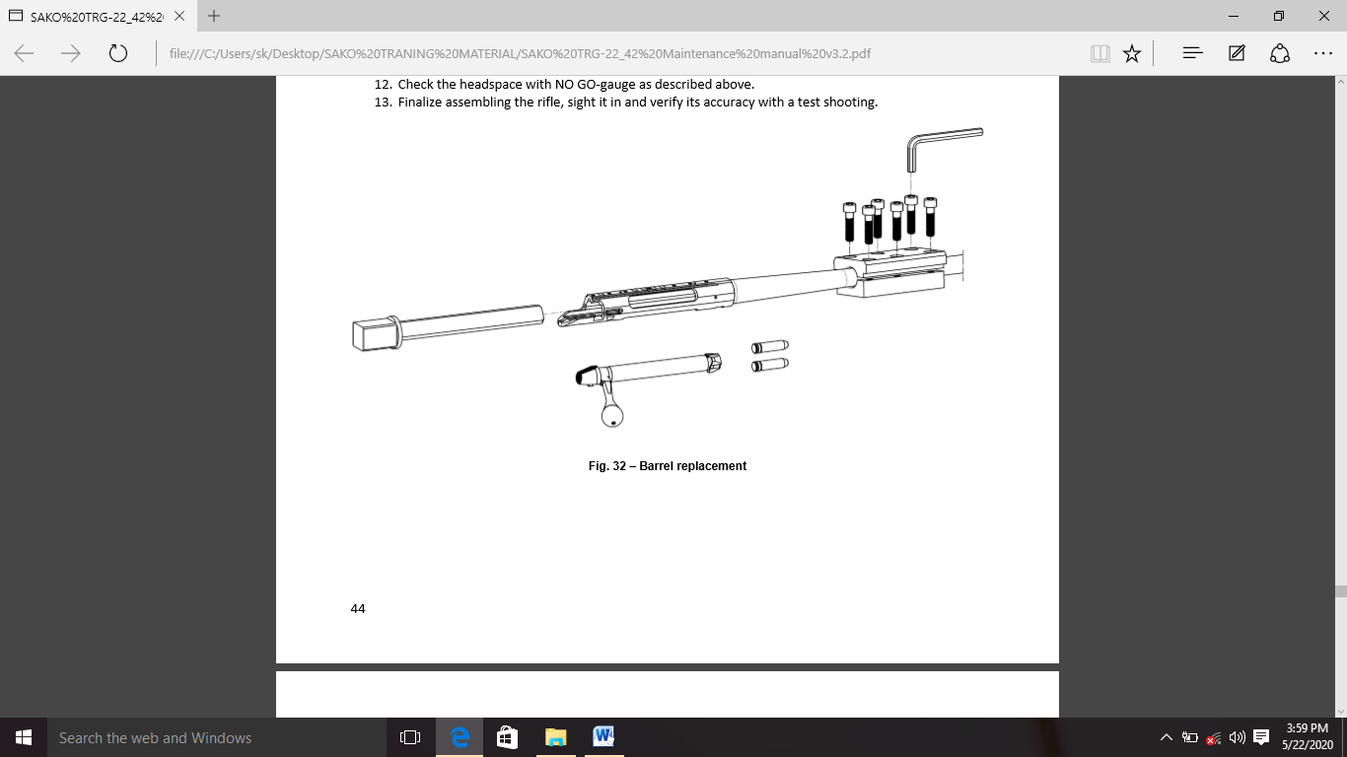

10. **Tests and Inspections**

**Gauges**

(a) Headspace gauge set, (GO and NO GO).

(b) Firing pin protrusion gej.

(c) Barrel wear gauge.

(d) Trigger pull scale (5N – 25N).

(a) **Inspecting Headspace Gauge Set, (GO and No GO)**

Head spacing ka inspection go-/no go-geuge ke saath kiya jaata hai. Chambar mein daale gaye go-geuge ke saath Bolt ko smoothly roop se close hona chaahie,

lekin chambar mein daale gaye go-gauge ke saath Bolt bilkul bhee close nahin hona chaahie.

hambar mein no go-geuge daalane ke saath, Bolt ko band karate samay excussive force se bachana chaahie. Isake result loking surface ka deformation ho sakata hai, jo badalein mein headaspes ke excessive wear mein contributes deta hai aur Bolt ke movement kathor ho jaatee hai. Yadi Bolt ko chaimbar mein daale gaye no go gauge ke saath clock kiya ja sakata hai, to Rifle ka upayog tab tak nahin kiya jana chaahie jab tak ki barral ya Bolt ko badalakar hed spacing ko theek nahi kiya jaata.

(b) **Inspecting the Firing Pin Protrusion (failav)** Firing pin protrusion (failav) ke inspection ke liye Bolt ko receiver se hatana chahiye aur Bolt shroud ko clockwise ghumakar decock kiya jana chahiye jab tak ki Firing pin decock na ho jaye.Firing pin protrusion ka uchit gauge ka use karke ya dial caliber ke sath maap kar inspection kiya jata hain.Bolt face se maapa jane par Firing pin failav( protrusion) 1.3-2.1 mm hona chahiye.Agar test fail hota hai to Firing pin assy ko badalna chahiye.Firing pin ko cocking wrench ke sath Bolt shroud ko clockwise ghumakar cock kiya jata hai.Jab tak ki sear apne resting groove me nahi ruk jaye .Id Test shooting ke result par based hona chahiye.

(c) **Inspecting Barrel Wear Gauge.**  Jyada fire karne ke karan barrel wear chamber throat/ free bore wear ke rup mein dikhai deta hai.Throat ki diameter crease me hoga our sath hi yeh muzzle ki taraf badh jayega.Throat wear ke karan rif ki accuracy bigad jata hai aur muzzle velocity kam hojata hai.Throat ka inspection karne ke liye barrel wear gauge ka istemal kiya ja sakta hai.Agar barrel wear gauge ko barrel ke chamber end se 200 mm se adhik bore me dhakela (Push) ja sakta hai barrel wear Ko remarkable mana ja sakta hai aur muzzle velocity ko kuch had tak kam karne ka karan ho sakta hai.Final judgment barrel ko badli ka hota hai.

(d) **Inspecting the Trigger Pull.** Rif ko cock karke trigger pull ka inspection kiya jata hai our fir ek dusre ke bich ki event ki comparing karte hue kai bar fire ki jati hai.

1. har ek trigger pull ko ek dusre ki tarah feel hona chahiye our Bolt bahut teji (rapidly) se band hone par rif ko cocked event rahana chahiye.Trigger mein clear pull hona chahiye our trigger brake point crisp(sharp,clean-cut and clear) hona chahiye.Trigger travel ke douran koi sticking( chipakna)Nahi chahiye.
2. Trigger pull weight ki check karne ke liye trigger pull scale ka use kiya jana chahiye. First pull ka weight 5N se kam nahi hona chahiye our second pull ka weight kam se kam 7N hona chahiye.
3. Agar trigger mech fulty paya gaya hai to isko ek spare ke sath replaced karna chahiye our fulty unit ko maintenance ke liye qualified person ko diya jana chahiye.
4. Scale ko trigger leaf ke bich me our har bar usi jagah par point kiya jana chahiye.
5. Jab adjustment key ko ek TORX T 10 key ka istemal karke clockwise ghumaya jata hai to trigger pull badh jayega.Trigger pull ka weight ko 3-5 lbs adjustment range ke sath adjust kiya ja sakta hai.Trigger pull weight ka adjusting first stage our sceond stage dono ko adjust karta hai,weight ko ek sath khichta hai .(pull karta hai).Adjustment ke baad adjusment screw ko locking agent ke sath lock karne ki jarurat nahi hai.

Note:- Trigger mech our safty ke sabhi inspection tavi kiya jaye jab rif cartridge se bilkul free ho.

(e) **Safety inspection.** Safety ke kaama karwai ko samay-samay par inspection kiya jana chaahie.

1. Pehle phase ka samann karne ke baad practical roop se koi trigger movement Safety switch on ke saath nahi hona chahiye. Thathapit Safety ka testing karte samye athiyadik takat (forcely) ka proyog na karein. Athiyadik takat (forcelly) se Safety mechanism ko nuksan pahunch sakta hai Aur iske Aushrinea operator ko zanam de sakta hai. Yadi trigger kekisi bi anuchit movement pahile kichne ke baad identified kiya jata hai. To trigger mechanism ko ek atrick ke saath replaced kiya jana chahiye Aur repair keliye blame unit ko ek Yoog rakhrakav karne keliye delivered kiya jana chahiye.

**Note:** Trigger mechanics Aur Safety ke sabhi inspection kiya jana chahiye jab Rifle cartridge se bilkul free(mukt) ho.

(c) **Barrel saafai ke prakriya**

(i) **Barrel ki safai*:*** Barrel ki sthiti Rifle ki shooting visheshtaon par bahut parbhab padta hai. Aur keval maich gred ammunition ka upayog karke fire dwara kiya Gaye shooting test dubara mazbutise nirdharit kiya ja sakta hai. Yadi shooting test (Firing) se pahile chalata hai ki barrel ki situation aparyaptai, ti barrel ok achi tara se cleaning kiya jan chahiye Aur refilling se sambhavit metal (dhaatu)se dhool ,metti ko hata Diya jana chayei, yadi cleaning se sthiti thik nahi hoti hai to barrel ko spair barrel se sath badal Diya jana chahiye

(ii)  **Bore ke safai**

(aa) Rifle se Bolt ko aata de Aur insure Karein ki chamber kali hai Aur magazin ko alag kar Diya Gaya hai

(ab) Receiver edge se bore ke cleaning Karein Aur rod guid ka istemal kar taki cleaning rod groves ko chhoone se tok sake.

(ac) Muzzle se baahar nikalne wale prayapt lambe cleaning rod ka istemal karein

(ad) Keval unche shrenee ke bor solvents Aur gun oil ka istemal karein

(ae) Bore solvent se bhigoe hue catton pacth ko barrel ke maadyam se tab tak suka karein jab ta ki suka paich muzzle se saf na dikhaee de.

(af) Bore ke safai samapt karne baad barrel ko high quality Rifle oil chindi ke madat se barrel ko saf karein.

(ag) Rifle ko fire karne se pehle ek saaf chindi ke madat se barrel ki sabi Rifle oil Aur grees ko hata diya jana chahiye .

(d) **Chamber cleaning:-** Yadi cartridge case chamber me chamber wall ke sath fash jaye to chamber ka inspection kiya jana chahiye, Missed scratch powder partical ko steel on ke sath chamber ko polish karke bahut savdani se chamber se hataya ja sakta hai. Barrel ko badali kar ke hi gambhir roop se scratch ya damage chamber ko thik kiya ja sakta hai.

(e) **Inspecting The Safety:-** Safety functioning ka samaye – samaye par nirikshan kiya jana chahiye.

(i) First stage ka enconterd(samna) karne ke baad practically koi bhi trigger movement safty switched ke sath nahi hona chahiye.Safty ka testing karte waqt jyada force ka istemal na karein.Jyada force se Safety mech ko nuksan pahucha sakta hai aur iske unreliable operation ko paida kar sakta hai.Yedi trigger ke kisi bhi unduc movement ko pahle khichne ke baad pehchana jata hai to trigger mech ko ek spare ke sath badalna chahiye aur faulty unit ko repair ke liye qualified maintenance person ko diya jana chahiye.

NOTE :- Trigger mech our Safety ke sabhi inspection tabhi kiya jaye jab rif cartridge se bilkul free ho.

(f) **Removing Fouling**

(i) Accuracy mein kami aksar bore fouling ke karan hoti hai, jahan

gilding metal rifling se chipak jate hai.

(ii) Isliye savdhani se bore ki cleaning ke saath-saath gandagi ko samay-samay par hataane par dhayan dena chaahie.

(iii) Bore Ka erosion accuracy par kafi kam prabhaav dalata hai, lekin bore ke asaan fouling ko banaye rkhata hai aur isalie accuracy par indirect prabhaav padata hai. Gambhir erosion vaale barrel ko spare se badala jana chaahie.

(g) **Muzzle Crown.** Muzzle Crown accuracy ke liye bahut important hai. Crown ki rifling ko possibley faultless aur symmetrical roop se cut karna chahie. Crown par chhote dent bhi accuracy ko vishesh roop se kam kar sakate hain. land dwara guided beveled reamer ka upayog karake crown ko recover kiya ja sakata hai. yadi Muzzle Crown buri tarah damage ho gaya hai to barrel ko spare ke saath badala jana chahiye.

**Maintenance Under Special Conditions**

12. Diye gaye guideline ke alawa, vishesh roop se kharab mausam ki sthiti mein TRG- 42 sniper rifel ki safai particular aur kharab Mausam ke sambandh mein bahari temperature, ambient humidity aur operation site ki nature ke sambandh mein vishesh niyamon ka paalan kiya jana chahiye neeche di gayi janakari mein vishesh roop se batayi gayi conditions mein upayog ke liye samany guidence shamil hain. vibhin bhagon ki cleaning aur lubrication bahut prabhavit karta hai, vishesh roop se abnormal situation me, kyuki ye excessive wear or damage hone se bachata hai. Agar maintance uchit nahi hai to zero se neeche ka temperature par wpn ka istemal ek Gambhir nukshan ho sakta hai. Yahi karan hai ki neeche di gayi situation me normal serving ko jaldi karna chahiye.

(a) **Low Temperatures me wpn ka istemal**

(i)Overall moving bhaagon par special care diya jana chaahie kyonki baraf ka nirmaan uchit phisalan ko affect karata hai.

(ii) Lubrication ka samay paalan karate hue lubricant ke sath acchi tar ha saf safayi karne bad junk ke kilaf extra Surkhsa ka roop me oil ki ek Aur Parth lagayen.

iii) Yadi chalane vaale purje baraf ke karan jaam ho jaate hain, to un par kabhee jor na daalen. operation ko successful karane ke lie unhen garm kiya jana chaahie.

(iv) Extra barf (ICE) ya paanee ko hata den jo hathiyar mein mil gaya ho.

(v) Extra jang, dust aur tel ke jamaav ko hata den, jo lubricant theek se kaam karane se rokega.

(vi) Kabhi bhi anti freeze ka prayog na karein.

(b) **Bahut garam ya humid conditions wpn ka use karna**

1. Lubricating schedule ka pallan karte hue lubricant se poori tarah se saf safayi karane ke baad, jang ke khilaf extra suraksha ke roop mein oil ki ek aur parth lagayen.
2. Kisie bhee condensate paanee ko turant hata den aur hathiyar ko achchhee tarah se saaf aur safayi kar len.
3. Sabhi mechanical moving purjon ko baar-baar hilaen.
4. Sabhi non painted kie gaye metal ke hisson ko pooree tarah se saaf rakhen aur grees kee ek parth lagayen.

(C) **sandy air dust bhare weather**

1. Sandy ya dust bhare vaataavaran mein pravesh karane se pehle, ret ko tel aur grees par chipakane se rokane ke lie baahar se dikhaee dene vaalee sliding surface lubricant ko hata den aur chalane vaale hisson ko gambheer pahanane se roken.
2. Sandy ya dust bhare vaataavaran mein pravesh karane se pehle, service hathiyar kee prescribed karein. Partical roop se, sliding surface per par jama sandy aur dust ko hata den.

13. **Preventive Maintenance**

Yeh bhag hathiyar ke kaam karte samay ki toot-phoot ke karan hone wali kharaabi ko rokane ke liye instructions deta hai. yadi kharaabi ki turant pehchan ki jaati hai aur karan ko khatm karne ke liye tatkaal karwai ki jaati hai to adhik serious damage se bacha ja sakta hai aur equipment ki operational status ko banaya rakha ja sakta hai. operators ki duty hathiyar ko hamesha jyada saavadhaani se handle kiya jana chahiye taaki anajaane mein discharge aur operational accident ko roka ja sake, jo aksar operator ki laaparavaahi se ya hathiyar ka kam knowledge hone ke karan hota hai. sabhi hathiyaron ki tarah, sako trg-22/42 Rifle ko use ke baad saaf aur lubricate kiya jana chahiye. Warning: Yakeen karein ki hathiyar amn se bhara hua nahin hai aur magazine hathiyar se baahar hai. Important: hathiyar specially bore ko saaf karne ke liye kabhi bhi emery paper, sand paper ya koi jyada khurdari chiz ka upayog na karein.

(a) Firing se pehle. Firing se pehle operating Safety ensure karne ke liye neeche diye hue procedure ko poora kiya jayega:

(i) Bolt ko hataa de aur barrel ko dekhte hue ensure karne ke liye dekhen ki barrel saath hi chamber saaf aur kisi bhi rukawat se mukt hain. goli chalne par ek chhoti si rukawat bhi barrel ko permanently nuksaan pahuncha sakti hai aur ek serious accident ka karan ban sakti hai.

(ii) Ejector aur extractor ki smoothness ke liye movement ko check karein. ensure karein ki springs kaaphi majaboot hain. yadi jaruri ho to dummy cartridge ke saath ejector aur extractor ke function ka test karein.

(iii) Magzine ko lagayen aur yakeen karein ki magazine lock sahi h aur Bolt daalen aur karwai ke order ki jaanch karein. Bolt properly khulna aur lagna chahiye.

(iv) Magzine ko lagayen aur yakeen karein ki magazine lock sahi h aur Bolt daalen aur karwai ke order ki jaanch karein. Bolt properly khulna aur lagna chahiye.

(v) Safety ke operation ki jaanch karein. Safety ka operation sateek/precise hona chahiye. Safety ke saath Rifle ko discharge nahin karna chahiye, jab trigger par jyada pressure lagaaya jaata hai. Halanki, jyada trigger dabaav se bacha jana chahiye, kyonki is se Safety mechanism ko nukasaan ho sakta hai aur yah unservicable ho sakta hai.

(vi) Fore-end, fixed rear stock ya folding stock, cheek piece aur recoil pad ke bandhan/fastening aur condition ki jaanch karein aur adjustments ko verify karein.

(vii) Kisi bhi hathiyar ko fire karne se pehle hamesha check kar len ki scope thik tareke se Kassa hua hai aur uske screw theek se kasse huye hai. yadi aap uske screw (jude) ko theek se kas nahi sakate hain to screw ko spair parts ya Rifle ke sath badal diya jana chaahie, jismen base ke saath dayare ko nirekshan aur marammat ke lie uchch Rakha-rakhaav star mein badal diya jana chaahie.

(viii) Muzzal break ke attchament ko haath se ghumaakar cheek karein. yadi muzzle break free roop se guhm jata hai to muzzle break ko thik karne ke lie hathiyar ko unit star ke armourer shop mein bhej diya jana chahiye.

(ix) Bipod ke saath-juden, hisson ko bhi check karien ki latches joint aur leg adjuster thik se kaam kar rha hain ya nahi.

(b) **Routine Maintenance**

(i) Firing se pehale barrel ko hamesha saaf karna chahiye. barrel mein atyadhik oil ya dust hone se jab fire hota hain, to barrel mein ubhaar (bulge) paida kar sakata hai aur barrel ko damage kar sakta hain

(ii) Kam temperature mein Firing se pehle aur uske dauran Bolt ko alag kiya jana chahiye aur Bolt ke part se oil ya grees ko hata diya jana chahiye, locking lugs ke cocking surface aur locking surface ko chod kar, jo hamesha barikee se grees hona chahiye. yah zero degree celisious se neeche ke sthitiyon mein Rifle ki achhe se fire karne ki sathiti ko badhayega.

(iii) Rifle ka niyamit rakharakhaav hamesha Rifle ke upayog ke baad hona chaahie. yadi shooting ke turant baad saaf safai nahi kiya jata hai, to barrel ke thanda hone ke baad barrel ka acchi tarike se saaf kiya jana chahiye.

(iv) Barrel ki safai aur chiknai hamesha breech ke madhyam se ki jani chahiye. Rifle ko nukasan se bachane ke liye rifke ki safai uske sath di gyi accessories se karni chahiye.

(c) **Rifle**

(i) Yakeen karien ki chamber khali hain.

(ii) Bolt aur mag ko hata den.

(iii) Bipod kholkar Rifle ko Bipod ke saath samatal satah par sahara den.

(iv) Agar Rifle geela ho jata hain to sampedit hawa ka upayog karke Rifle ko sukhayien ya bina kisi surakshaatmak cover yani drage bag ke garm / sookhe sthaan par sukhane deyien.

(v) Barrel ko pahle lubricanted aur fir dry cotton patches ko barrel ke madhyam se ek ke baad ek tabtak saaf kare jabtak ki patch per koi gandgi dikhai na de.

(vi) Muzzle brake ko oil wale kapde se or cleaning kit me diye gaye nilon brush se pauch kar cleaning kit me diye gaye stapper ke sath nischit manatanence procces ke ek bhag ke roop me carbon residule ko hatne ke sath sath possible flash ko hataya jata hai.

(vii) Barrel ko saaf karne ke baad isme light film protective lubricant ko apply kiya jana chiye.

(viii) Parts ko clean karne ke liye described procedure ka palan karte hua bolt ko alag kare aur unpar protective lubricant ki ek halki parat lagaye.

(ix) Rif ko dust, durst aadi se achi tarah se saaf kare aur sabhi metals ki surface ko oil wale kapde se lubricate kare taki rif par lubricant ki ek halki parat bani rahe.

(x) Sling swivel mount ko Lubricate kare aur apn and attachments ka inspection kare.

(xi) Proposed maintenance schedule ka palan karte hua, described procedure ka palan karte hua mag ko alag kare aur mag box per aur ander lubricant ki halki parat lagaye aur mag ko firse re-assable kare.

(d) **Bipod.** Bipod ko oil lage kapde se asaf kare. Puri safai ke liye bipod ko puri tarah bahar kichle, safai finish karne ke baad bipod per ek halki lubricant ki parat lagaye.

(e) **Other Accessories.** Anye accessories ko clean rakhe. Rif bag or siling ko dry akre aur kisi bhi dry dust ko brush karke saaf kare.assesories ko kabhi bhi wet rif bag me na chode, unhe drag bag se tabtak nikale jabtak ki vah puri tarha se dry na hojaye.

**Storage Instructions**

14. Yadi weapon ko lambe samay tak (max 24 month) tak store kiya jana hai, to niman anushar aghe badhe.

(a) Section 3 me specified wpn ko Disassemble kare.

(b) Lubricant ki jarurat wale wpn , wpn ke sabhi components ko pahle uchit solvent ka use karke saaf kiya jana chiye.

(c) Cleaned aur dried component ko break free grade III oil ya equivalent ke sath achi tarah se lubricate kiya jana chiye.

**Important:** Confirm kare ki shamil componets ki puri tarha lubricant ki ek parat ke sath saman roop se cover kiya ho.

(d) Weapon ko fir se jora ja sakta ha aur 12 month ke liye kisi additional routine maintanence ki jaruat ke bina rakha ja sakta ha, jiske baad upper kiya described procces ko dohraya gaya hai.

(e) Break free grade oil se treat kiya gaya wpn ko bina kishi maintainance direct fire kiya ja shakta hai.Halaki Firing se pehle barrel mein hui kishi sukhe kapde (chindi)ka istemal karke barrel ko saaf karne ki advice di jati hai.

**Note**: - Brake- free grade III oil ka istemal karte samay Teflon based component ko barkarar rakhne ke liye istemal karne se pehle isse achhi tarah se hilayen,(quki yeh bottle ki neeche jama ho jata hai).

**Cleaning kit**

15. SAKO TRG – 42 ki maintainance ke liye firer ko field cleaning/tool kit diya ja shakte hai.cleaning kit mein nimnalikhit tool samil hai.

(a) Sectional rod with T-handle

(b) Nylon Brush

(c) Bronze brushes

(d) Patch holder

(e) Patches

(f) Lubricant / cleaning solvent

(g) Carrying case

16. **Troubleshooting – Possible Causes and Remedies**

|  |  |  |
| --- | --- | --- |
| **Malfunction** | **Possible Cause** | **Remedy(solution)** |
| Bolt band nahi. | Bolt cock nahi hai. | Bolt ko cock karein. |
| Faulty cartridge | Cartridge ko badly karein. |
| Gandha chamber | Chamber ko saaf karein. |
| Action is damaged | Rifle ko repair karo. |
| Hathiyar ko cock nahi kiya ja shakta. | Trigger mechi ko sahi se na rakhna. | Trigger mechanism ki fasting ko check karein. |
| Gharshan/ragar ya damage ke karan cocking piece or sear mein ring ho jana | Rifle ko repair ke liye le jayen. |
| Trigger mechanism mein gandhagi or dhul mitti jama ho jana. | Rifle ko repair ke liye le jayen. |
| Misfires. | Faulty cartridge. | Badli karein |
| Bolt ke ander kharab or purana oil. | Bolt or Firing pin ko saaf karein |
| Damaged Firing pin spring | Badli karein. |
| Damaged Firing pin. | Rifle ko repair ke liye le jayen. |
| Galat  chambering. | Bolt movement mein kami. | Use goal-directed and exact movements of the Bolt, which are to be finished in one go. |
| Magazine mein gandhagi. | Mag ko alag karein or saaf karein. |
| Magazine galat tarik se bharna. | Magazine ko sahi se bharen. |
| Galat extraction. | Kharab extractor. | Rifle ko repair ke liye le jayen. |
| Ejector spring sahi se fit nahi | Rifle ko repair ke liye le jayen. |
| Galat ejection. | Damaged/fasa huwa ejector. | Rifle ko repair ke liye le jayen. |
| Ejector spring sahi se fit nahi. | Rifle ko repair ke liye le jayen. |
| Triggering sahi nahi. | Dhile or tirchhi trigger mech | Trigger mech ki fastening ko check. |
| Trigger mech ke andar gandagi ya purana oil. | Trigger mech ka sahi se adjust na hona. |
| Improperly adjusted trigger mech. | Instructions ke mutabik first pull or trigger weight ko adjust karein. |
| Kharab trigger mechanism. | Rifle ko repair ke liye le jayen. |
| Accuracy sahi nahi. | Sight mounting dhila. | Sight braket ko check karein. |
| Body rail per receiver ki mounting dhili hona. | Mounting screws ko check karein. |
| Barrel mein gandagi jamna. | Barrel se gilding metal ko nikalna. |
| Muzzle brake se ek hi disha mein flashes ka nikalna. | Rifle ko repair ke liye le jayen |
| Damaged sight. | Alag sight ka istemal karke check karein. |